13.2.6 Claims Windows

This Window section contains a list of the functional groups and a brief description of each. The Claims subsystem uses a number of Windows that are identified by purpose of use or Functional Group. The online functional groups in the PDCS OS PLUS Claims subsystem listed in this section are:

- The Batch Control functional group contains windows that allow the user to search, view and maintain existing batch control information or create a new batch for exam entry of claims, credits, or adjustments.
- The Batch Release functional group contains a window used to release claim batches for other users to access. When a user selects a batch from the Exam Entry, Adjustment, or Credit Search tabs, the selected batch is locked to prevent others from simultaneously keying documents for the same batch. If multiple users are entering documents for the same batch, the first user must release the batch before the next user may add to it. Once entry of all documents in a batch is complete, the batch is automatically locked to prevent further entry.
- The Exam Entry functional group contains windows that allow the user to enter batches of claims submitted on paper claims forms. A claim batch control record must be on file prior to the entry of a batch of claims.
- The Adjustment functional group contains windows that allow the user to enter batches of claim adjustments submitted on paper adjustment request forms. An adjustment batch control record must be on file prior to the entry of a batch of adjustments.
- The Mass Adjustment functional group contains contains windows that allow the user to manage selection lists and process lists and TCNs for mass adjustments.
Each of these is described in detail separately, beginning below.

13.2.6.1 Batch Control Functional Group
This functional group provides the user the ability to:
- Inquire on batch control data
- Update batch control data
- Add a new batch
The following tab windows are used by the Batch Control Functional Group:
- Search
- Batch Control
The following data is displayed in the title bar of all tab windows (i.e., not on search windows) in this functional group:
- Customer name and ID
- Batch key (comprised of medium indicator, Julian date, batch number)

New Mexico PDCS OS PLUS Claims Subsystem
Window Specification
Batch Control Functional Group
Batch Control Search Window

Window Name: Batch Control: Batch Control Search
Description:
The Batch Control Search Window allows access to Batch Control information. Authorized users can use this window to add new batches or search for existing Batch Control Records, and select Batch Control records for display and update. This window displays Exam Entry, Adjustment and Credit batches for a specified date.

Window Type:
Response window

Navigation:
The user enters this window by clicking on the Batch Control selection on the Claims subsystem menu.
The user enters search criteria for a batch on the Batch Control Search Window. The search criterion consists of the 5-digit Julian Date. The Batch Number field is optionally used to refine the search.

Clicking on the Add Batch link displays the Batch Control window for entry of a new batch control record.

Clicking on the Batch Key of an existing batch displays the Batch Control window with the information from the selected batch.

Interface to Other Subsystem(s):
N/A

Interface to Other Application(s):
N/A

Special Security Requirements:
Access to batch control data is controlled by the user’s security profile.

Presentation Sequence(s):
The data displayed is sorted by “Batch Key” in ascending order.

Remarks:
N/A

New Mexico PDCS OS PLUS Claims Subsystem
Window Layout
Batch Control Functional Group
Batch Control Search Window

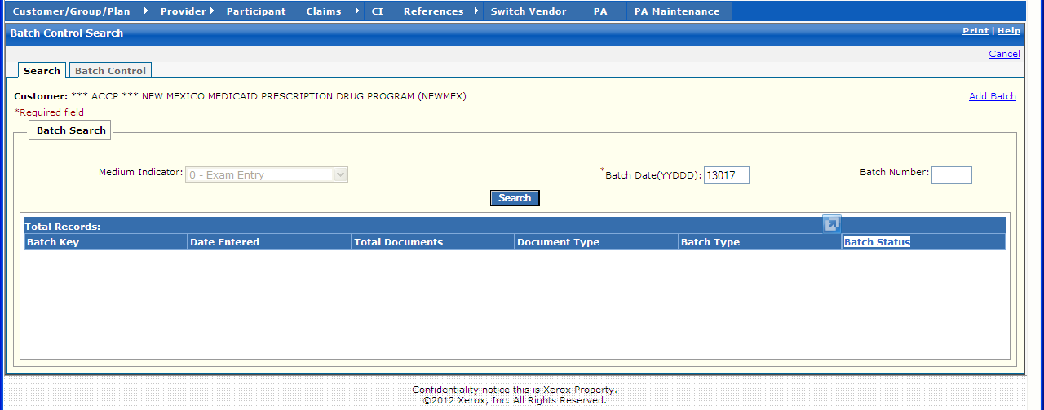

New Mexico PDCS OS PLUS Claims Subsystem
Window Exhibit
Batch Control Functional Group
Batch Control Search Window
Field Name | Table Column Name | Table Name | Format | Prot. (A,C,N) | Req.  (A,C,N) | Std. Edits | Specifications | Note  Ref.
Customer | R-CUST-PART-NUM | B_DETAIL_NM | 9,999 | A | N/A | N/A | Display Header
Batch Search Entry | Group | N/A | Grid | N/A | N/A | N/A | Grouping
Add Batch | N/A | N/A | Link | N | N | N/A | Click this link to open a blank Batch Control page.
Medium Indicator | C_BAT_MED_SRC_CD | C_BAT_CNTL_TB | Drop-down | N | N | V | Valid selection values with description presented to user.  Default value = “0- Exam Entry”.  User may scroll this box and select appropriate option.  Valid Value 0142
Batch Date  (YYDDD) | C_BAT_JLN_DT_NUM | C_BAT_CNTL_TB | X(5) | N | A | D | Format: YYDDD  Must be a valid date  Default value = 5-digit Julian Date
Batch Number | C_BAT_NUM | C_BAT_CNTL_TB | X(4) | N | N | N | Must be 4 digits in length
Command Button | Group | N/A | Button Row | N/A | N/A | N/A | Grouping
Search | N/A | N/A | Push Button | N | N | N/A | If selected, list box is populated with batches matching the search criteria
Batch Search Display | Group | N/A | Grid | N/A | N/A | N/A | Grouping
Batch Key | C_BAT_MED_SRC_CD  C_BAT_JLN_DT_NUM  C_BAT_NUM | C_BAT_CNTL_TB | X(1)  X(5)  X(4) | A | N | N/A | Concatenation of Medium Indicator, Batch Date, and Batch Number.  Valid Value 0142
Date Entered | C_BAT_ENTRY_DT | C_BAT_CNTL_TB | DATE | A | N | N/A | Format: MM/DD/YYYY
Total Documents | C_BAT_DOC_CNT_NUM | C_BAT_CNTL_TB | X(5) | A | N | N/A
Document Type | C_BAT_DOC_TY_CD | C_BAT_CNTL_TB | X (1) | A | N | N/A | Valid Value 0161
Batch Type | C_BAT_TY_CD | C_BAT_CNTL_TB | X (1) | A | N | N/A | Valid Value 0140
Batch Status | C_BAT_STAT_CD | C_BAT_CNTL_TB | X (1) | A | N | N/A | Valid Value 0122
Total Records | N/A | N/A | Display | A | N | N/A | Computed as total number of records meeting the search criteria

Legend
Prot. and Req. | Standard Edits | Note Ref.
A = Always | D = Date Edit | C = Customer-specific field or functionality
C = Conditionally | N = Numeric Edits | R = Note Reference
N = Never | S = System Generated
 | V = Valid Value Edit

Ref. No. | Notes
N/A | N/A

New Mexico PDCS OS PLUS Claims Subsystem
Window Specification
Batch Control Functional Group
Batch Control Detail Window

Window Name: Batch Control: Batch Control Detail
Description:
The Batch Control Detail Window displays an existing batch and provides inquiry, update, and delete capability for the batch selected. A batch can be deleted if documents have been entered for that batch. However, if the batch is re-created, you could not enter claims with batch numbers that already have a TCN associated with them. This window is also used to enter the data for a new Batch Control record.

Window Type:
Response Window

Navigation:
The user enters this window from the Batch Control Search window by clicking on a Batch Key or by clicking on the Add Batch link. Clicking on the Save or Delete button returns the user to the Batch Control Search window.

Interface to Other Subsystem(s):
N/A

Interface to Other Application(s):
N/A

Special Security Requirements:
Access to batch control data is controlled by the user’s security profile.

Presentation Sequence(s):
N/A

Remarks:
When an existing batch control record is displayed, a Show Last Update link is available. Selection of this link displays the date, time, and user id of the last update to this batch.

New Mexico PDCS OS PLUS Claims Subsystem
Window Layout
Batch Control Functional Group
Batch Control Detail Window

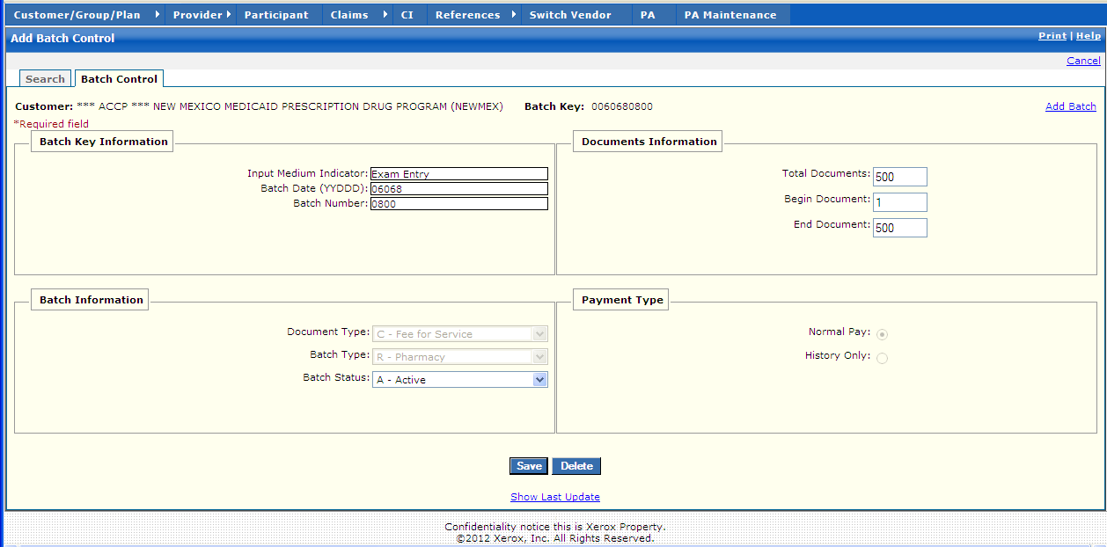

New Mexico PDCS OS PLUS Claims Subsystem
Window Exhibit
Batch Control Functional Group
Batch Control Detail Window
Field Name | Table Column Name | Table Name | Format | Prot. (A,C,N) | Req.  (A,C,N) | Std. Edits | Specifications | Note  Ref.
Customer | R-CUST-PART-NUM | B_DETAIL_NM | 9,999 | A | N/A | N/A | Display Header
Batch Key | C_BAT_MED_SRC_CD  C_BAT_JLN_DT_NUM  C_BAT_NUM | C_BAT_CNTL_TB | X(1)  X(5)  X(4) | A | N | N/A | Valid Value 0142 Concatenation of Medium Indicator, Batch Date and Batch Number
Add Batch | N/A | N/A | Link | N | N | N/A | Clicking on this link opens a blank Batch Control page.
Batch Key Information | N/A | N/A | N/A | N/A | N/A | N/A | Grouping
Input Medium Indicator | C_BAT_ MED_SRC_CD | C_BAT_CNTL_TB | Drop-down | N | A | V | Defaults to 0 – Exam Entry. This value cannot be changed.  Valid Value 0142
Batch Date  (YYDDD) | C__BAT_JLN_DT_NUM | C_BAT_CNTL_TB | X(5) | A | A | D | Format: YYDDD  Must be a valid date  Defaults to 5-digit Julian Date. | R1
Batch Number | C_BAT_NUM | C_BAT_CNTL_TB | X(4) | C | A | N | Must be 4 digits in length | R1  C1
Batch Information | N/A | N/A | N/A | N/A | N/A | N/A | Grouping
Document Type | C_BAT_DOC_TY_CD | C_BAT_CNTL_TB | Drop-down | N | A | V | Valid values with descriptions are displayed.  Valid Value 0161 | R1
Batch Type | C_BAT_TY_CD | C_BAT_CNTL_TB | Drop-down | N | A | V | Valid values with descriptions are displayed.  Valid Value 0141 | R1
Batch Status | C_BAT_STAT_CD | C_BAT_CNTL_TB | Drop-down | A | A | V | Valid values with descriptions are displayed. Defaults to A - Active when a batch is added.  Valid Value 0122 | R2
Document Information | N/A | N/A | N/A | N/A | N/A | N/A | Grouping
Total Documents | C_BAT_DOC_CNT_NUM | C_BAT_CNTL_TB | X(6) | N | C | N | Total number of documents in the batch. Default value is = “500”.
Begin Document | C_BAT_BEG_DOC_NUM | C_BAT_CNTL_TB | X(6) | N | C | N | First document number in the batch.  Default value is = “1”.
End Document | C_BAT_END_DOC_NUM | C_BAT_CNTL_TB | X(6) | N | C | N | Last document number in the batch.  Default value is = “500”.
Payment Type | N/A | N/A | N/A | N/A | N/A | N/A | Grouping
Normal Pay | C_BAT_PYMT_TY_CD | C_BAT_CNTL_TB | Radio Button | A | N | N/A | User selects either the Normal Pay or History Only option. Default is Normal Pay. | R1
History Only | C_BAT_PYMT_TY_CD | C_BAT_CNTL_TB | Radio Button | A | N | N/A | User selects either the Normal Pay or History Only option. Default is Normal Pay. | R1
Command Buttons | Group | N/A | Button Row | N/A | N/A | N/A | Grouping
Save | N/A | N/A | Push Button | N | N | N/A
Delete | N/A | N/A | Push Button | N | N | N/A | The user must reply to a confirmation decision box. | R3

Legend
Prot. and Req. | Standard Edits | Note Ref.
A = Always | D = Date Edit | C = Customer-specific field or functionality
C = Conditionally | N = Numeric Edits | R = Note Reference
N = Never | S = System Generated
 | V = Valid Value Edit

Ref. No. | Notes
R1 | These fields can be entered for a new batch but cannot be maintained for an existing batch.
R2 | These fields can be maintained for an existing batch but cannot be entered for a new batch.
R3 | Only the users who have security access have access to delete a batch.
C1 | New Mexico Specific Batch numbers are 0800 - 0899

13.2.6.2 Batch Release Functional Group

This functional group provides the user the ability to:

- Review all batches locked with the user’s ID
- Release locked batches

The following tab windows are used by the Batch Release Functional Group:

- Locked Batches Information

The following data is displayed in the title bar of all tab windows (i.e., not on search windows) in this functional group:

- Customer name and ID

New Mexico PDCS OS PLUS Claims Subsystem
Window Specification
Batch Release Functional Group
Locked Batches Information Window

Window Name: Batch Release: Locked Batches Information
Description:
Whenever a user selects a batch from the Exam Entry, Adjustment, or Credit Search window to begin data entry, the selected batch is locked with the user’s ID to prevent others from keying documents for the same batch. If another user needs to enter data for a batch for which documents have been entered, the current owner of the batch must manually release (unlock) that batch using the Batch Release function. This window provides a list of all the batches the user currently has locked.

The batch is automatically locked when all documents have been entered and cannot be unlocked.

The user can select one or more batches and press the “Unlock” button.

Window Type:
Response Window

Navigation:
The user enters this window by clicking on the Batch Release selection on the Claims subsystem menu.

Interface to Other Subsystem(s):
N/A

Interface to Other Application(s):
N/A

Special Security Requirements:
Access to data is controlled by the user’s security profile. Only those batches locked with the user’s ID are displayed.

Presentation Sequence(s):
The system displays the data sorted by Batch Key in ascending order.

Remarks:
N/A

New Mexico PDCS OS PLUS Claims Subsystem
Window Layout
Batch Release Functional Group
Locked Batches Information Window

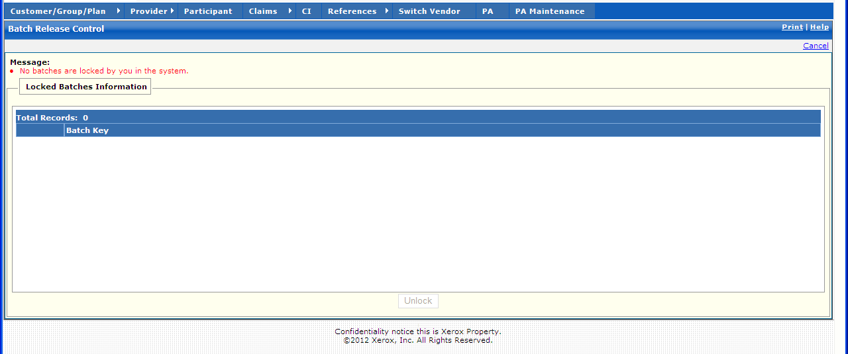

New Mexico PDCS OS PLUS Claims Subsystem
Window Exhibit
Batch Release Functional Group
Locked Batches Information Window
Field Name | Table Column Name | Table Name | Format | Prot. (A,C,N) | Req.  (A,C,N) | Std. Edits | Specifications | Note  Ref.
Batch Key | C_BAT_MED_SRC_CD  C_BAT_JLN_DT_NUM  C_BAT_NUM | C_BAT_CNTL_TB | X(1)  X(5)  X(4) | A | N | N/A | Valid Value 0142  This includes a check box used to select a batch
Total Records | N/A | N/A | Display | A | N | N/A | Computed as total number of records meeting the search criteria
Command Button | Group | N/A | Button Row | N/A | N/A | N/A | Grouping
Unlock | N/A | N/A | Push Button | N | N | N/A

Legend
Prot. and Req. | Standard Edits | Note Ref.
A = Always | D = Date Edit | C = Customer-specific field or functionality
C = Conditionally | N = Numeric Edits | R = Note Reference
N = Never | S = System Generated
 | V = Valid Value Edit

Ref. No. | Notes
N/A | N/A

13.2.6.3 Exam Entry Functional Group

This functional group provides the user the ability to:

- Display batch control, documents, exception code, and history information for Exam entered claims.

The following tab windows are used by the Exam Entry Functional Group:

- Search
- Doc List
- Claim
- Line Items
- Misc. Fields
- Misc. Tables
- History

The following data is displayed in the title bar of all tab windows (i.e., not on search windows) in this functional group:

- Customer name and TCN

New Mexico PDCS OS PLUS Claims Subsystem
Window Specification
Exam Entry Functional Group
Exam Entry Search Window

Window Name: Exam Entry: Exam Entry Search
Description:
The Claim Exam Entry Search Window allows the user to enter selection criteria to locate the batch control record (i.e., exam entry claims, adjustments, and credits) related to a batch of claims.
The Batch Date is required. The Batch Number field can be used to refine the search. Information for all batches with the same Batch Date is displayed in the list box.

All batch control records with Batch Type “R” and Document Type “C” (Exam Entry) are displayed here.

Window Type:
Response Window

Navigation:
The user enters this window by clicking on the Exam Entry menu selection while in the Claims subsystem. Click on Batch key to proceed to exam entry.

Interface to Other Subsystem(s):
N/A

Interface to Other Application(s):
N/A

Special Security Requirements:
Access to data is controlled by the user’s security profile.

Presentation Sequence(s):
The system displays the data sorted by Batch Key in ascending order.

Remarks:
N/A

New Mexico PDCS OS PLUS Claims Subsystem
Window Layout
Exam Entry Functional Group
Exam Entry Search Window
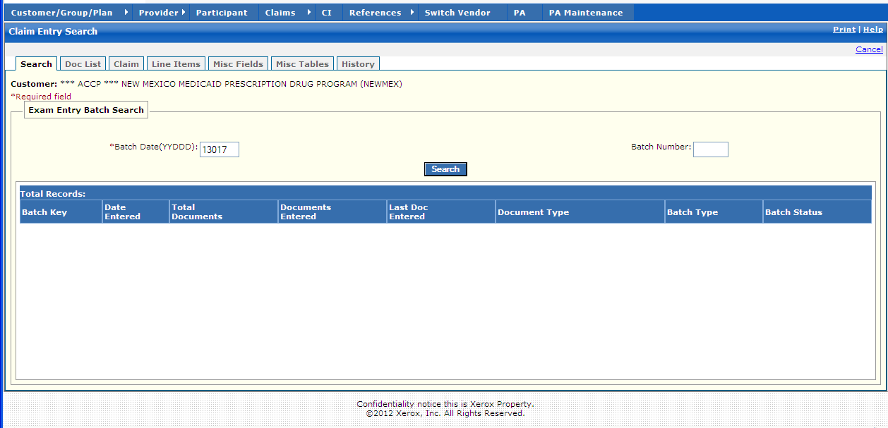

New Mexico PDCS OS PLUS Claims Subsystem
Window Exhibit
Exam Entry Functional Group
Exam Entry Search Window
Field Name | Table Column Name | Table Name | Format | Prot. (A,C,N) | Req.  (A,C,N) | Std. Edits | Specifications | Note  Ref.
Customer | R-CUST-PART-NUM | B_DETAIL_NM | 9,999 | A | N/A | N/A | Display Header
Exam Entry Batch Search Entry | Group | N/A | Group | N/A | N/A | N/A | Grouping
Batch Date  (YYDDD) | C_BAT_JLN_DT_NUM | C_BAT_CNTL_TB | X(5)  Date | A | A | D | Format: YYDDD  Must be a valid date  Date Defaults to 5-digit Julian Date.
Batch Number | C_BAT_NUM | C_BAT_CNTL_TB | X(4) | N | N | N | Must be 4 digits in length
Command Button | Group | N/A | Button Row | N/A | N/A | N/A | Grouping
Search | N/A | N/A | Push Button | N | N | N/A | When pressed, batches meeting the Search Criteria are displayed in the multi-column list box.
Exam Entry Batch Search Display | Group | N/A | Group | N/A | N/A | N/A | Grouping
Batch Key | C_BAT_MED_SRC_CD  C_BAT_JLN_DT_NUM  C_BAT_NUM | C_BAT_CNTL_TB | X(1)  X(5)  X(4) | A | N | N/A | Concatenation of Medium Indicator, Batch Date and Batch Number
Date Entered | C_BAT_ENTRY_DT | C_BAT_CNTL_TB | Date | A | N | N/A | Format: MM/DD/CCYY
Total Documents | C_BAT_DOC_CNT_NUM | C_BAT_CNTL_TB | Long Integer | A | N | N/A | Count representing the total number of claims entered in the batch.
Documents Entered | C_DOC_ENTR_CNT_NUM | C_BAT_CNTL_TB | Long Integer | A | N | N/A | The running count of the number of documents (claims) entered so far within this batch.
Last Doc Entered | C_LAST_ENTRD_NUM | C_BAT_CNTL_TB | Long Integer | A | N | N/A | Last document number entered in the batch of claims. It is possible to skip a document number in a batch.
Document Type | C_BAT_DOC_TY_CD | C_BAT_CNTL_TB | X(1) | A | N | N/A | Valid Value 0161
Batch Type | C_BAT_TY_CD | C_BAT_CNTL_TB | X(1) | A | N | N/A | Valid Value 0140
Batch Status | C_BAT_STAT_CD | C_BAT_CNTL_TB | X(1) | A | N | N/A | Valid Value 0122
Total Records | N/A | N/A | Display | A | N | N/A | Computed as total number of records meeting the search criteria

Legend
Prot. and Req. | Standard Edits | Note Ref.
A = Always | D = Date Edit | C = Customer-specific field or functionality
C = Conditionally | N = Numeric Edits | R = Note Reference
N = Never | S = System Generated
 | V = Valid Value Edit

Ref. No. | Notes
N/A | N/A
New Mexico PDCS OS PLUS Claims Subsystem
Window Specification
Exam Entry Functional Group
Exam Entry Documents Window

Window Name: Exam Entry: Exam Entry Documents
Description:
The Exam Entry Documents Window allows for the display of additional claims for the participant within the batch selected. This tab only appears during Exam Entry, Claims Adjustment, and Claims Credit.

Window Type:
Response Window

Navigation:
The user enters this window by clicking on the Doc List tab.

Interface to Other Subsystem(s):
N/A

Interface to Other Application(s):
N/A

Special Security Requirements:
Access to data is controlled by the user’s security profile.

Presentation Sequence(s):
The records are sorted by document number.

Remarks:
N/A

New Mexico PDCS OS PLUS Claims Subsystem
Window Layout
Exam Entry Functional Group
Exam Entry Documents Window

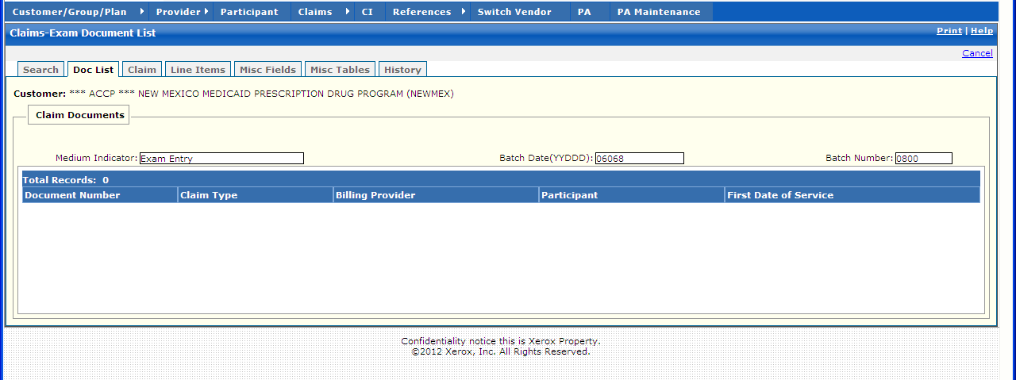

New Mexico PDCS OS PLUS Claims Subsystem
Window Exhibit
Exam Entry Functional Group
Exam Entry Documents Window
Field Name | Table Column Name | Table Name | Format | Prot. (A,C,N) | Req.  (A,C,N) | Std. Edits | Specifications | Note  Ref.
Customer | R-CUST-PART-NUM | B_DETAIL_NM | 9,999 | A | N/A | N/A | Display Header
Claim Documents Entry | Group | N/A | Group | N/A | N/A | N/A | Grouping
Medium Indicator | C_BAT_ MED_SRC_CD | C_BAT_CNTL_TB | X(1) | C | C | V | Valid Value 0142 | R1
Batch Date (YYDDD) | C__BAT_JLN_DT_NUM | C_BAT_CNTL_TB | X(5) | C | C | D | Format: YYDDD  Must be a valid date | R1
Batch Number | C_BAT_NUM | C_BAT_CNTL_TB | X(4) | C | C | N | Must be 4 digits in length | R1
Claim Documents Display | Group | N/A | Group | N/A | N/A | N/A | Grouping
Document Number | C_HDR_DOC_NUM | C_BAT_CNTL_TB | X (6) | A | N | N/A
Claim Type | C_BAT_TY_CD | C_BAT_CNTL_TB | X (1) | A | N | N/A | Valid Value 0140
Billing Provider | P_SVC_PHARM_ALT_ID | C_LI_DRUG_TB | X(15) | A | N | N/A
Participant | B_CRDHLDR_ALT_ID | C_LI_DRUG_TB | X(20) | A | N | N/A
First Dateof Service | C_HDR_SVC_FST_DT | C_LI_DRUG_TB | DATE | A | N | N/A | Format: MM/DD/CCYY
Total Records | N/A | N/A | Display | A | N | N/A | Computed as total number of records meeting the search criteria

Legend
Prot. and Req. | Standard Edits | Note Ref.
A = Always | D = Date Edit | C = Customer-specific field or functionality
C = Conditionally | N = Numeric Edits | R = Note Reference
N = Never | S = System Generated
 | V = Valid Value Edit

Ref. No. | Notes
R1 | This field is prepopulated from Exam Entry, Adjustment, or Credit batch information.
New Mexico PDCS OS PLUS Claims Subsystem
Window Specification
Exam Entry Functional Group
Claim Exam Entry Window

Window Name: Exam Entry: Claim Exam Entry
Description:
The Claim Exam Entry Window is presented to authorize users to enter/edit pharmacy claim data. Also, authorized users utilize the Claim Exam Entry Window to enter/review claim information related to pharmacy services. This window is only accessible for claims created from a batch that was specified as batch type of pharmacy, and document type of Fee For Service (FFS).

The user may enter a batch date at the Exam Entry Search window and selects a batch key for entry into the Claim Exam Entry Window.

The Claim Exam Entry Window opens with a system-generated TCN allowing the user to enter a claim.

The Participant pane contains fields to allow entry of Participant information. Minimum Participant fields required to enter a Claim are Social Security Number with an ID Type of 97 – Client Specific ID.

The Provider pane allows entry of the Pharmacy ID and Prescriber ID. Minimum Provider fields required to enter a Claim are NCPDP of the dispensing pharmacy with an ID Type of 07 – NCPDP Provider Type and the DEA Number of the prescribing physician.

The COB pane allows for entry of Coordination of Benefits indicator. COB indicator is not a required field.

The Rx Information pane allows entry of Prescription or Service information. Minimum Rx Information fields required to enter a Claim are Rx/Service #, Submit Days, Submit Qty, Drug NDC #, Date Written, Date Filled and Qty Prescribed.

The Pricing Pane allows entry of Pricing information. Minimum Pricing fields required to enter a Claim are Submit Ingredient Cost and Total Charge.

The Other Information pane allows entry of Override information.

Window Type:
Response Window

Navigation:
The user enters this window by selecting a batch on the Exam Entry search window.

After entering a claim, the user may select one of the following options:
CONTINUE – If submitting a multi-line compound, click “Continue” to move to additional data entry windows.
SAVE – the record is saved and the Claims tab remains open for entry on the next claim.
VERIFY – the record is saved; Edits appear for correction; the claim can be submitted for processing.
SUBMIT – the record is saved, the claim is processed and added to the database; the claim is available for viewing in Claims Inquiry

Interface to Other Subsystem(s):
Adjudication happens here – Interfaces to all PDCS OS PLUS subsystems such as Participant, Provider, and Reference.

Interface to Other Application(s):
N/A

Special Security Requirements:
Access to data is controlled by the user’s security profile.

Presentation Sequence for Exceptions:
Line Item number, Exception Number

Remarks:
N/A

New Mexico PDCS OS PLUS Claims Subsystem
Window Layout
Exam Entry Functional Group
Claim Exam Entry Window

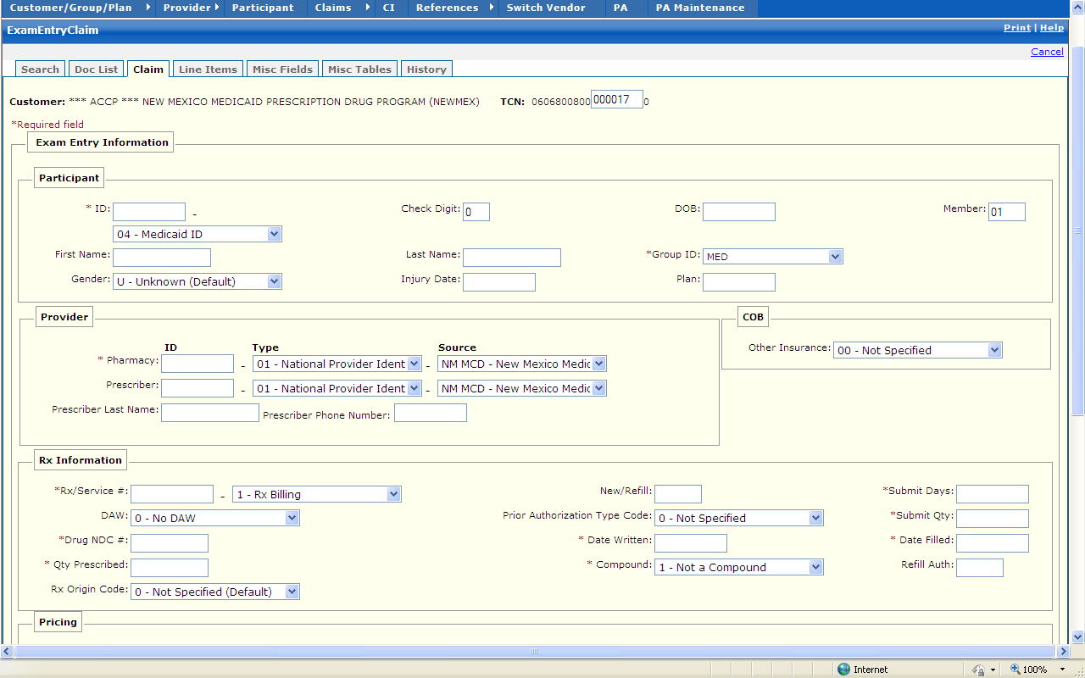
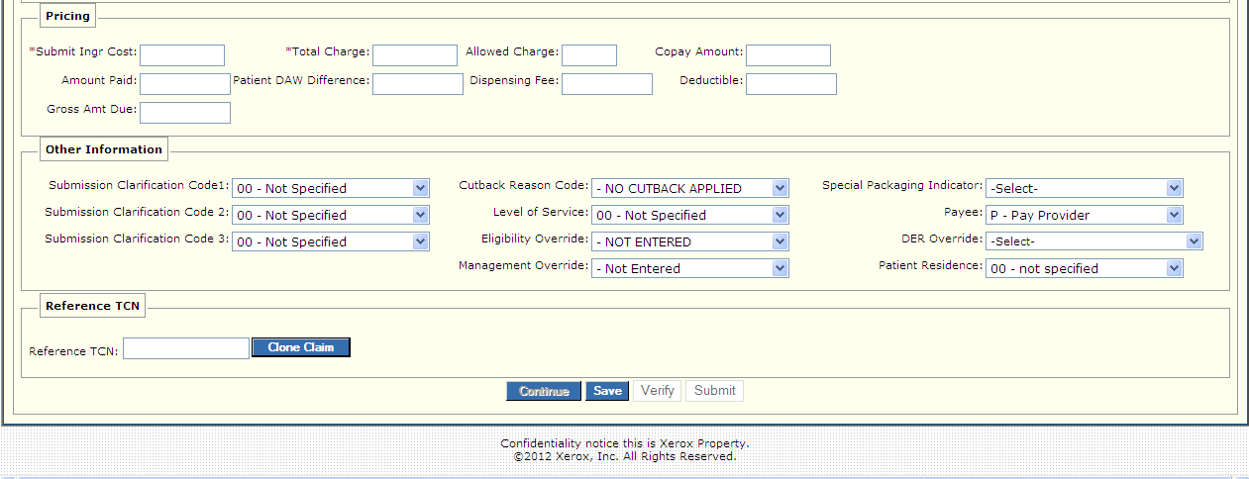

New Mexico PDCS OS PLUS Claims Subsystem
Window Exhibit
Exam Entry Functional Group
Claim Exam Entry Window
Field Name | Table Column Name | Table Name | Format | Prot. (A,C,N) | Req.  (A,C,N) | Std. Edits | Specifications | Note  Ref.
Customer | R-CUST-PART-NUM | B_DETAIL_NM | 9,999 | A | N/A | N/A | Display Header
Exam Entry Information | Group | N/A | Group | N/A | N/A | N/A | Grouping
Participant | N/A | N/A | N/A | N/A | N/A | N/A | Grouping
ID | B_CRDHLDR_ALT_ID  B_CRDHLD_ALT_ID_CD | C_LI_DRUG_TB | X(20)  Drop-down | N  N | A  A | N  V | Valid value 0255  Defaults to “04” Medicaid ID
First Name | B_FST_NAM | C_HDR_TB | X(30) | N | N | N/A
Gender | B_GENDER_CD | C_HDR_TB | Drop-down | N | N | V | Valid Value 0229
Check Digit | B-CHK_DIG_NUM | C_HDR_TB | Small Integer | N | N | N/A
Last Name | B_LST_NAM | C_HDR_TB | X(35) | N | N | N/A
Injury Date | C-HDR-INJURY-DT | C-HDR-TB | DATE | N | C | D | Must be a valid date
Member | B-MBR-NUM | C_LI_DRUG_TB | X(4) | N | C | N/A
DOB | B_DOB_DT | C_HDR_TB | DATE | N | N | D | Format: MM/DD/CCYY
Group ID | R_GROUP_ID | C_LI_DRUG_TB | Drop-down | N | A | N/A | Defaults to “MED”
Plan | R_PLAN_ID | C_LI_DRUG_TB | X(3) | N | N | N/A
Provider | Group | N/A | Group | N/A | N/A | N/A | Grouping
Pharmacy ID | P_SVC_PHARM_ALT_ID | C_LI_DRUG_TB | X(15) | N | A | N
Prescriber ID | P_PRSC_ALT_ID | C_LI_DRUG_TB | X(15) | N | A | N
Pharmacy Type | P_SVC_PH_ALT_ID_CD | C_LI_DRUG_TB | Drop-down | N | A | V | Valid Value 4844 | C1
Prescriber Type | P_PRSC_ALT_ID_CD | C_LI_DRUG_TB | Drop-down | N | A | V | Valid Value 2693
Pharmacy Source | P_SPH_ALT_ID_TY_CD | C_LI_DRUG_TB | Drop-down | N | A | V | Valid Value 0526 | C1
Prescriber Source | P_PRS_ALT_ID_TY_CD | C_LI_DRUG_TB | Drop-down | N | A | V | Valid Value 5139
COB | NA | N/A | N/A | N/A | N/A | N/A | Grouping
Other Insurance | C_OTHR_INS_IND | C_HDR_TB | Drop-down | N | N | V | Defaults to 00  Valid Value 3078
Rx Information | N/A | N/A | N/A | N/A | N/A | N/A | Grouping
Rx/Service # | C_RX_SVC_REF_NUM  C_RX_SVC_REF_CD | C_LI_DRUG_TB | 9(12) | N  N | A | N  V | Defaults to 01-Rx Billing  Valid Value 9049
DAW | C_DAW_CD | C_HDR_DRUG_TB | Drop-down | N | N | V | Valid Value 0249. Defaults to 0
Qty Prescribed | C_QTY_PRSC_AMT | C_HDR_DRUG_TB | X(7) | N | A | N
New/Refill | C_RX_REFILL_NUM | C_HDR_DRUG_TB | X(2) | N | N | N
Prior Authorization Type Code | C_PA_TY_CD | C_LI_DRUG_TB | Drop-down | N | N | V | Valid Value 0596
Date Written | C_DRUG_PRESCR_DT | C_LI_DRUG_TB | DATE | N | A | D | Format: MM/DD/CCYY  Must be a valid date
Compound | C_DRUG_CMPND_CD | C_LI_DRUG_TB | Drop-down | N | A | V | Valid Value 0824
Submit Days | C_SUB_DAY_SPLY_AMT | C_LI_DRUG_TB | X(3) | N | A | N
Submit Qty | C_SUBM_ING_QTY_AMT | C_LI_DRUG_TB | X(8) | N | A | N
Date Filled | C_HDR_SVC_FST_DT | C_LI_DRUG_TB | DATE | N | A | D | Format: MM/DD/CCYY  Must be a valid date
Refill Auth | C_REFIL_AUTH_NUM | C_HDR_DRUG_TB | X(2) | N | N | N
Pricing | N/A | N/A | N/A | N/A | N/A | N/A | Grouping
Submit Ingr Cost | C_SUBM_INGRED_CST_AMT | C_LI_DRUG_TB | X(7) | N | A | N
Amount Paid | C_LI_REIMB_AMT | C_LI_DRUG_TB | X(7) | N | N | N
Gross Amount Due | C_DRUG_GROSS_AMT | C_HDR_DRUG_TB | X(5)v99 | N | N | N
Total Charge | C_TOT_CHRG_AMT | C_LI_DRUG_TB | X(9)V99 | N | A | N
Patient DAW Difference | C_PAT_DAW_DIF_AMT | C_HDR_DRUG_TB | X(9)V99 | N | N | N
Allowed Charge | C_CALC_ALLOW_AMT | C_LI_DRUG_TB | X(9)V99 | N | N | N
Dispensing Fee | C_DISP_FEE_AMT | C_LI_DRUG_TB | X(9)V99 | N | N | N
Copay Amount | C_TOT_COPAY_AMT | C_LI_DRUG_TB | X(9)V99 | N | N | N
Deductible | C_HDR_DRUG_DED_AMT | C_LI_DRUG_TB | X(9)V99 | N | N | N
Other Information | N/A | N/A | N/A | N/A | N/A | N/A | Grouping
Submission Clarification Code 1 | C_DRUG_RX_OVRRD_CD | C_LI_DRUG_TB | X(2) | A | N | N/A | Valid Value 0874
Submission Clarification Code 2 | C_DRUG_RX_OVRRD_CD2 | C_LI_DRUG_TB | X(2) | A | N | N/A | Valid Value 0874
Submission Clarification Code 3 | C_DRUG_RX_OVRRD_CD3 | C_LI_DRUG_TB | X(2) | A | N | N/A | Valid Value 0874
Cutback Reason Code | C_CTBCK_RSN_CD | C_LI_DRUG_TB | Drop-down | N | N | V | Valid Value 5426
Level of Service | C_LVL_OF_SVC_CD | C_HDR_DRUG_TB | Drop-down | N | N | V | Valid Value 4468
Eligibility Override | C_ELIG_OVRRD_IND | C_HDR_DRUG_TB | Drop-down | N | N | V | Valid Value 0882
Patient Location | C_PAT_LOC_CD | C_HDR_TB | Drop-down | N | N | V | Valid Value 5668
Unit Dose | C_UNIT_DOSE_CD | C_HDR_DRUG_TB | Drop-down | N | N | V | Valid Value 3575
Management Override | C_MGMT_OVRRD_IND | C_HDR_DRUG_TB | Drop-down | N | N | V | Valid Value 0112
Payee | C_DRUG_PAYEE_CD | C_HDR_DRUG_TB | Drop-down | N | N | V | Valid Value 0857
DER Override | C_DER_OVRRD_CD | C_LI_DRUG_TB | Drop-down | N | N | V | Valid Value 6987
Reference TCN | N/A | N/A | N/A | N/A | N/A | N/A | Grouping
Reference TCN
Clone Claim | N/A | N/A | Press Button | N | N | N/A | When pressed, claim is Cloned.
Command Buttons | Group | N/A | Button Row | N/A | N/A | N/A | Grouping
Continue | N/A | N/A | Press Button | N | N | N/A | When pressed, claim is saved and the Line Items page is opened to enter information for compound drugs.
Save | N/A | N/A | Press Button | N | N | N/A | When pressed, the claim is saved and the Exam Entry window remains open to enter the next Claim.
Verify | N/A | N/A | Press Button | N | N | N/A | When pressed, the claim is saved and edits appear for correction, if appropriate. The claim can be submitted for processing.
Submit | N/A | N/A | Press Button | N | N | N/A | When pressed, the claim is saved, processed, and added to the database. The claim is available for viewing in Claims Inquiry.

Legend
Prot. and Req. | Standard Edits | Note Ref.
A = Always | D = Date Edit | C = Customer-specific field or functionality
C = Conditionally | N = Numeric Edits | R = Note Reference
N = Never | S = System Generated
 | V = Valid Value Edit

Ref. No. | Notes
C1 | If Pharmacy Type is Valid Value “07 – NCPDP Provider ID” then Pharmacy Source must be Valid Value “NCPDP – NCPDP”.
New Mexico PDCS OS PLUS Claims Subsystem
Window Specification
Exam Entry Functional Group
Line Items Window

Window Name: Exam Entry: Line Items
Description:
The Line Items Window is presented to authorized users to enter pharmacy claim line item data for compound drugs and to add submitted Prior Authorization Numbers if included on a paper claim (including both CMS and/or BlueCross PAs).

If the claim is for a compound drug, each ingredient is entered using this window. If the claim is for a single-ingredient drug, only one record appears. This window can support up t o 99 line items with a suggested maximum of 25 ingredients.

Information such as Ingredient Drug Cost, Ingredient Cost, and Drug NDC Number is specified and if adding a line item, these fields are required.

If the claim is for a non-compound and the user is adding a submitted PA number, that line item can be updated with the PA number in the Prior Auth ID field.

Lines can be added, updated, or deleted.

Window Type:
Response Window

Navigation:
The user enters this window by clicking on the Exam Entry tab while in the Claims subsystem. The user selects the Line Items tab. Exam Entry Line Items Window can also be accessed if the user chooses to CONTINUE for compound drug processing from the Exam Entry Claim Window.

Interface to Other Subsystem(s):
PDCS OS PLUS Reference to validate NDC

Interface to Other Application(s):
N/A

Special Security Requirements:
Access to data is controlled by the user’s security profile.

Remarks:
Delete option requires a confirmation.

New Mexico PDCS OS PLUS Claims Subsystem
Window Layout
Exam Entry Functional Group
Line Items Window

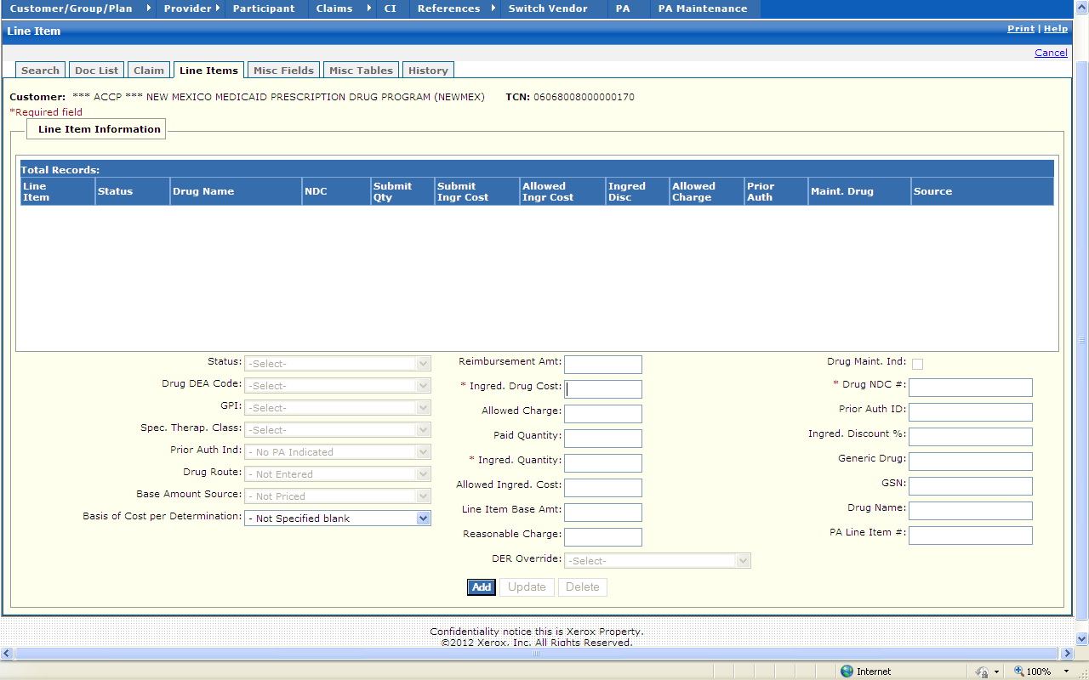

New Mexico PDCS OS PLUS Claims Subsystem
Window Exhibit
Exam Entry Functional Group
Line Items Window
Field Name | Table Column Name | Table Name | Format | Prot. (A,C,N) | Req.  (A,C,N) | Std. Edits | Specifications | Note  Ref.
Customer | R-CUST-PART-NUM | B_DETAIL_NM | 9,999 | A | N/A | N/A | Display Header
TCN | C_TCN_NUM | C_LI_DRUG_TB | X(17) | A | N/A | N/A | Displays the Transaction control number of particular claim.
Line Item Information Display | N/A | N/A | N/A | N/A | N/A | N/A | Grouping
Line Item | C_LI_NUM | C_LI_DRUG_TB | X(2) | A | N | N/A
Status | C_REIMB_STAT_CD | C_LI_DRUG_TB | X(1) | A | N | N/A | Valid Value 0162
Drug Name | R_DRUG_NAM | C_LI_DRUG_TB | X(30) | A | N | N/A
NDC | R_DRUG_CD | C_LI_DRUG_TB | X(11) | A | N | N/A
Submit Qty | C_SUBM_ING_QTY_AMT | C_LI_DRUG_TB | X(8)v9  (3) | A | N | N/A
Submit Ingr  Cost | C_SUBM_ING_CST_AMT | C_LI_DRUG_TB | X(7)v9  (2) | A | N | N/A
Allowed Ingr Cost | C_LI_ING_ALLOW_AMT | C_LI_DRUG_TB | X(9)v9  (2) | A | N | N/A
Ingred Disc | C_INGRED_DISCT_PCT | C_LI_DRUG_TB | X(3)v9  (2) | A | N | N/A
Allowed Charge | C_CALC_ALLOW_AMT | C_LI_DRUG_TB | X(9)v9  (2) | N | N | N/A
Prior Auth | A_ID | C_LI_DRUG_TB | X(11) | A | N | N/A
Maint. Drug | C_DRUG_MAINT_IND | C_LI_DRUG_TB | X(1) | A | N | N/A | Valid Value 0848
Source | C_BSE_AMT_SRC_CD | C_LI_DRUG_TB | X(2) | A | N | N/A | Valid Value 0167
Total Records | N/A | N/A | Display | A | N | N/A | Computed as total number of records meeting the search criteria
Line Item Information Entry | N/A | N/A | N/A | N/A | N/A | N/A | Grouping
Status | C_REIMB_STAT_CD | C_LI_DRUG_TB | Drop-down | N | N | V | Valid Value 0162
Drug DEA Code | C_DRUG_DEA_CD | C_LI_DRUG_TB | Drop-down | N | N | V | Valid Value 0314
GPI | R_DRUG_GEN_PRD_CD | C_LI_DRUG_TB | Drop-down | N | N | V | Valid Value 1839
Spec. Therap. Class | R_DRG_THR_CHAR3_CD | C_LI_DRUG_TB | Drop-down | N | N | V | Valid Value 1804
Prior Auth Ind | C_PRIOR_AUTH_IND | C_LI_DRUG_TB | Drop-down | N | N | V | Valid Value 1142
Drug Route | C_DRUG_ROUTE_CD | C_LI_DRUG_TB | Drop-down | N | N | V | Valid Value 0872
Base Amount Source | C_BSE_AMT_SRC_CD | C_LI_DRUG_TB | Drop-down | N | N | V | Valid Value 0167
Basis of Cost per Determination | C_BASIS_COST_CD | C_LI_DRUG_TB | Drop-down | N | N | V | Valid Value 9136
Reimbursement Amt | C_LI_REIMB_AMT | C_LI_DRUG_TB | X(9) | N | C | N/A
Ingred Drug Cost | C_SUBM_ING_CST_AMT | C_LI_DRUG_TB | X(9) | N | A | N/A
Allowed Charge | C_CALC_ALLOW_AMT | C_LI_DRUG_TB | X(9) | N | C | N/A
Paid Quantity | C_LI_PD_QTY_AMT | C_LI_DRUG_TB | X(9) | N | C | N/A
Ingred. Quantity | C_SUBM_ING_QTY_AMT | C_LI_DRUG_TB | X(9) | N | A | N/A
Allowed Ingred. Cost | C_LI_ING_ALLOW_AMT | C_LI_DRUG_TB | X(9) | N | C | N/A
Line Item Base Amt | C_LI_BSE_AMT | C_LI_DRUG_TB | X(9) | N | C | N/A
Reasonable Charge | C_DRUG_GROSS_AMT | C_HDR_DRUG_TB | X(9) | N | C | N/A
DER Override | C_DER_OVRRD_CD | C_LI_DRUG_TB | Drop-down | N | N | V | Valid Value 6987
Drug Maint Ind | C_DRUG_MAINT_IND | C_LI_DRUG_TB | Check Box | N | N | V | Valid Value 0848
Drug NDC # | R_DRUG_CD | C_LI_DRUG_TB | X(11) | A | N | N/A
Prior Auth ID | A_ID | C_LI_DRUG_TB | S9(11) | N | C | N
Ingred Discount % | C_INGRED_DISCT_PCT | C_LI_DRUG_TB | S9(3)v9  (2) | N | C | N
Generic Drug | C_DRUG_GEN_CD_NUM | C_LI_DRUG_TB | X(5) | N | C | N
GSN | R_DRUG_GCN_SEQ_NUM | C_LI_DRUG_TB | S9(6) | N | C | N
Drug Name | R_DRUG_NAM | C_LI_DRUG_TB | X(30) | N | C | N
PA Line Item # | A_LI_NUM | C_LI_DRUG_TB | S9(4) | N | C | N
Command Buttons | Group | N/A | Button Row | N/A | N/A | N/A | Grouping
Add | N/A | N/A | Push Button | N | N | N/A
Update | N/A | N/A | Push Button | N | N | N/A
Delete | N/A | N/A | Push Button | N | N | N/A

Legend
Prot. and Req. | Standard Edits | Note Ref.
A = Always | D = Date Edit | C = Customer-specific field or functionality
C = Conditionally | N = Numeric Edits | R = Note Reference
N = Never | S = System Generated
 | V = Valid Value Edit

Ref. No. | Notes
N/A | N/A
New Mexico PDCS OS PLUS Claims Subsystem
Window Specification
Exam Entry Functional Group
Miscellaneous Fields Window

Window Name: Exam Entry: Miscellaneous Fields
Description:
Authorized users utilize the Exam Entry Miscellaneous Fields Window to enter/edit claim information associated with partial and completion fill claims and other miscellaneous NCPDP 5.1 information.

Window Type:
Response Window

Navigation:
The user enters this window by selecting the Misc. Fields tab.

Interface to Other Subsystem(s):
PDCS OS PLUS Provider to validate Provider

Interface to Other Application(s):
N/A

Special Security Requirements:
Access to data is controlled by the user’s security profile.

Remarks:
N/A

New Mexico PDCS OS PLUS Claims Subsystem
Window Layout
Exam Entry Functional Group
Miscellaneous Fields Window

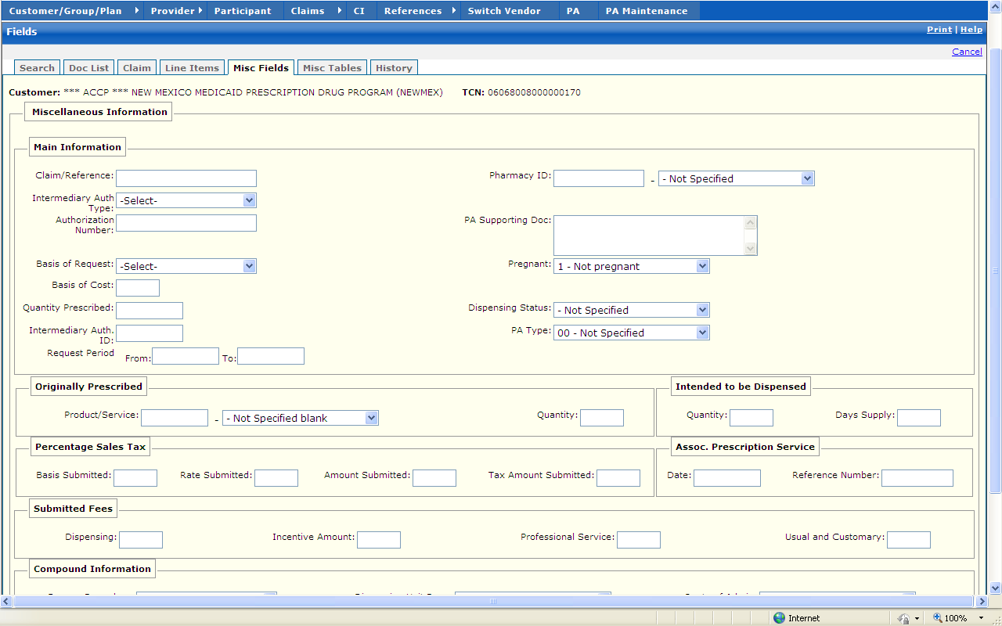

New Mexico PDCS OS PLUS Claims Subsystem
Window Exhibit
Exam Entry Functional Group
Miscellaneous Fields Window
Field Name | Table Column Name | Table Name | Format | Prot. (A,C,N) | Req.  (A,C,N) | Std. Edits | Specifications | Note  Ref.
Customer | R-CUST-PART-NUM | B_DETAIL_NM | 9,999 | A | N/A | N/A | Display Header
TCN | C_TCN_NUM | C_LI_DRUG_TB | X(17) | A | N/A | N/A | Displays the Transaction control number of particular claim.
Miscellaneous Information | N/A | N/A | N/A | N/A | N/A | N/A | Grouping
Main Information | N/A | N/A | N/A | N/A | N/A | N/A | Grouping
Claim/Reference | C_CLM_REF_ID_NUM | C_HDR_TB | X(30) | N | N | N/A
Intermediary Auth Type | C_INTMDRY_AUTH_CD | C_HDR_TB | Drop-down | N | N | V | Valid Value 8642
Authorization Number | A_AUTH_NUM | C_HDR_TB | X(20) | N | N | N
Basis of Request | C_PA_BASIS_REQ_CD | C_HDR_TB | Drop-down | N | N | V | Valid Value 9032
Basis of Cost | C_BASIS_COST_CD | C_LI_DRUG_TB | X(2) | N | N | V | Valid Values 9136
Quantity Prescribed | C_QTY_PRSC_AMT | C_HDR_DRUG_TB | X(7)V99 | N | N | N
Intermediary Auth ID | C_INTMDRY_AUTH_ID | C_HDR_TB | X(11) | N | N | N/A | Intermediary Authorization
Request Period From | C_PA_REQ_BEG_DT | C_HDR_TB | DATE | N | C | D | Format: MM/DD/CCYY  Must be a valid date
Request Period To | C_PA_REQ_END_DT | C_HDR_TB | DATE | N | C | D | Format: MM/DD/CCYY  Must be a valid date
Pharmacy ID | P_PHARM_ALT_ID  P_PHARM_ALT_ID_CD | C_HDR_DRUG_TB | X(15)  Drop-down | N  N | C  N | N/A  V | Valid Value 2693
Prescriber ID | P_PRSC_ALT_ID  P_PRSC_ALT_ID_CD | C_LI_DRUG_TB | X(15)  Drop-down | N  N | C  N | N/A  V | Valid Value 6987
PA Supporting Doc | C_PA_SUP_DOC_TX | C_HDR_TB | List Box | N | N | N/A
Pregnant | C_PRGNCY_IND | C_HDR_TB | Drop-down | N | N | V | Valid Value 9269
Dispensing Status | C_DISP_STATUS_CD | C_LI_DRUG_TB | Drop-down | N | N | V | Valid Value 8723
PA Type | C_PA_TYP_CD | C_LI_DRUG_TB | Drop-down | N | N | V | Valid Value 0596
Originally Prescribed | N/A | N/A | N/A | N/A | N/A | N/A | Grouping
Product/Service | C_ORG_PROD_SVC_ID  C_ORG_PROD_SVC_CD | C_HDR_DRUG_TB | X(19)  Drop-down | N  N | C  N | N/A  V | Valid Value 6580
Quantity | C_ORG_QTY_PRSC_AMT | C_HDR_DRUG_TB | X(7)V99 | N | N | N
Intended to be Dispensed | N/A | N/A | N/A | N/A | N/A | N/A | Grouping
Quantity | C_INT_DISP_QTY_AMT | C_HDR_DRUG_TB | X(7)V99 | N | N | N
Days Supply | C_INT_DISP_DAY_NUM | C_HDR_DRUG_TB | X(3) | N | N | N
Percentage Sales Tax | N/A | N/A | N/A | N/A | N/A | N/A | Grouping
Basis Submitted | C_SUBM_PCT_TX_CD | C_HDR_DRUG_TB | X(2) | N | N | V | Valid Value 2890
Rate Submitted | C_SUBM_PCT_RT_AMT | C_HDR_DRUG_TB | X(3)V9999 | N | N | N
Amount Submitted | C_SUBM_PCT_TX_AMT | C_HDR_DRUG_TB | X(7)V99 | N | N | N
Tax Amount Submitted | C_SUBM_TAX_AMT | C_HDR_DRUG_TB | X(9)V2 | N | N | N
Assoc. Prescription Service | N/A | N/A | N/A | N/A | N/A | N/A | Grouping
Date | C_ASOC_RX_SVC_DT | C_HDR_DRUG_TB | DATE | N | C | D | Format: MM/DD/CCYY  Must be a valid date
Reference Number | C_ASOC_RX_SVC_NUM | C_HDR_DRUG_TB | X(7) | N | N | N
Submitted Fees | N/A | N/A | N/A | N/A | N/A | N/A | Grouping
Dispensing | C_SUBM_DSP_FEE_AMT | C_HDR_DRUG_TB | X(6)V99 | N | N | N
Incentive Amount | C_SUBM_INCNTVE_AMT | C_HDR_DRUG_TB | X(6)V99 | N | N | N
Professional Services | C_SUBM_PRO_FEE_AMT | C_HDR_DRUG_TB | X(6)V99 | N | N | N
Usual and Customary | C_UC_CHARGE_AMT | C_HDR_DRUG_TB | X(6)V99 | N | N | N
Compound Information | N/A | N/A | N/A | N/A | N/A | N/A | Grouping
Dosage Form desc | C_DSG_FM_DESC_CD | C_HDR_DRUG_TB | Drop-down | N | N | V | Valid Value 7054
Dispensing Unit Form | C_DISP_UNT_FM_CD | C_HDR_DRUG_TB | Drop-down | N | N | V | Valid Value 8811
Route of Admin | CLM-RT-ADMIN-CD | C_HDR_DRUG_TB | Drop-down | N | N | V | Valid Value 9532
Command Button | Group | N/A | Button Row | N/A | N/A | N/A | Grouping
Save | N/A | N/A | Push Button | N | N | N/A

Legend
Prot. and Req. | Standard Edits | Note Ref.
A = Always | D = Date Edit | C = Customer-specific field or functionality
C = Conditionally | N = Numeric Edits | R = Note Reference
N = Never | S = System Generated
 | V = Valid Value Edit

Ref. No. | Notes
N/A | N/A
New Mexico PDCS OS PLUS Claims Subsystem
Window Specification
Exam Entry Functional Group
Miscellaneous Tables Window

Window Name: Exam Entry: Miscellaneous Tables
Description:
Authorized users utilize the Exam Entry Miscellaneous Tables window to enter/edit claim information for repeating segments.

The Exam Entry Miscellaneous Tables window contains information pertaining to DUR, Procedure Modifier codes associated with physician services, Other Amounts associated with additional costs incurred for a dispensed prescription or service, Clinical information, Diagnosis Code, and COB Paid/Reject information.

Window Type:
Response Window

Navigation:
The user enters this window by selecting the Misc. Tables tab.

Interface to Other Subsystem(s):
N/A

Interface to Other Application(s):
N/A

Special Security Requirements:
Access to data is controlled by the user’s security profile.

Presentation Sequence for DUR/PPS:
DUR/PPS Line Item number

Presentation Sequence for Procedure Modifier:
Procedure Modifier Line Item number

Presentation Sequence for Other Payer Coverage:
Other Payer Coverage Line Item number

Presentation Sequence for Other Payer Amount:
Other Payer Amount Line Item number

Presentation Sequence for Other Payer Reject:
Other Payer Reject Line Item number

Presentation Sequence for Clinical Segment:
Clinical Line Item number

Presentation Sequence for Diagnosis:
Diagnosis Code Line Item Number

Remarks:
4 – DUR/PPS table max set at 9

5 – Procedure Modifier table max set at 4

6 – COB table max set at 5

7 – COB paid table max set at 9

8 – COB reject table max set at 5

9 – Clinical table max set at 5

10 – Diagnosis table max set at 5

11 – COB patient responsibility max set at 25

12 – COB benefit stage max set at 4

New Mexico PDCS OS PLUS Claims Subsystem
Window Layout
Exam Entry Functional Group
Miscellaneous Tables Window

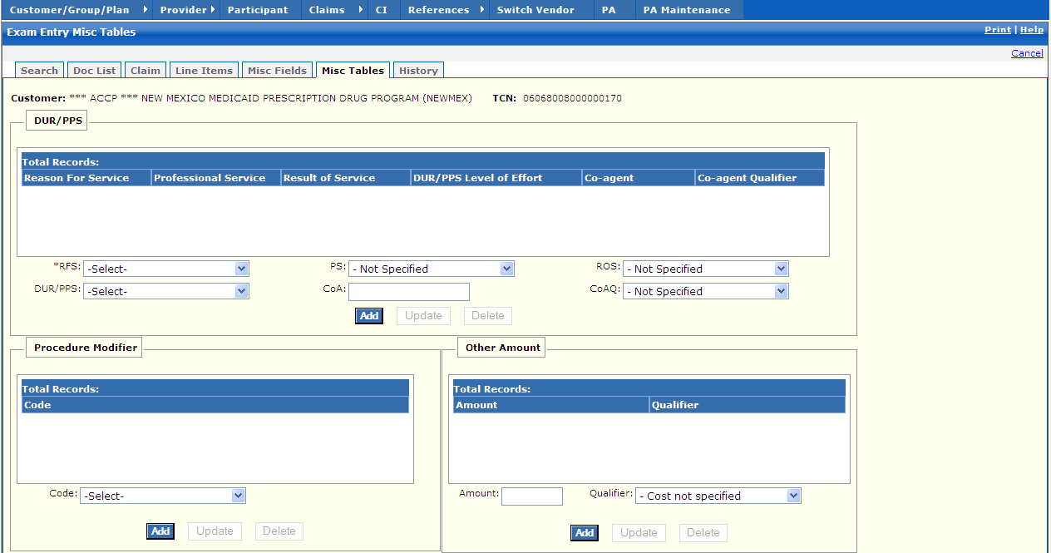

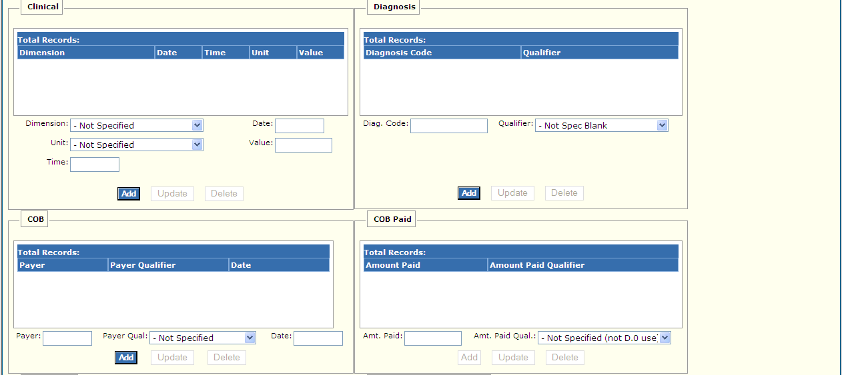
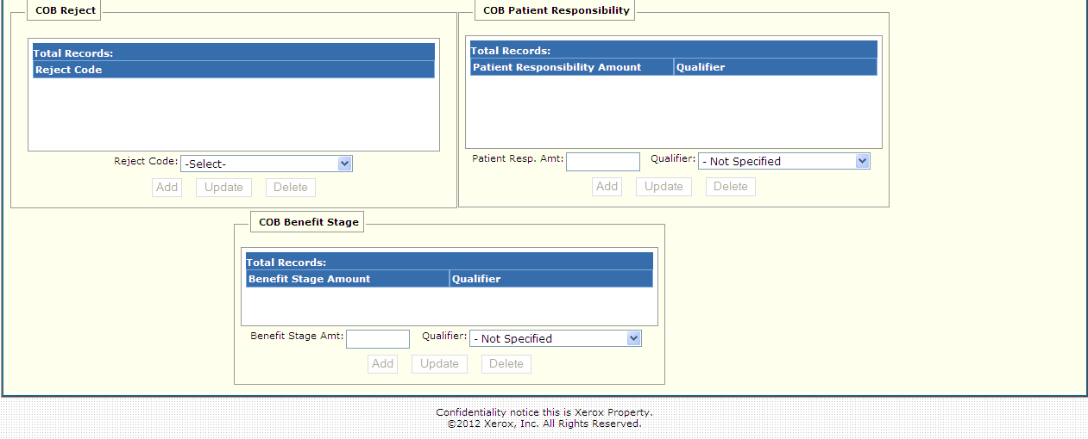

New Mexico PDCS OS PLUS Claims Subsystem
Window Exhibit
Exam Entry Functional Group
Miscellaneous Tables Window
Field Name | Table Column Name | Table Name | Format | Prot. (A,C,N) | Req.  (A,C,N) | Std. Edits | Specifications | Note  Ref.
Customer | R-CUST-PART-NUM | B_DETAIL_NM | 9,999 | A | N/A | N/A | Display Header
TCN | C_TCN_NUM | C_LI_DRUG_TB | X(17) | A | N/A | N/A | Displays the Transaction control number of particular claim.
DUR/PPS Display | N/A | N/A | N/A | N/A | N/A | N/A | Grouping
Reason for Service | R_RSN_FOR_SVC_CD | C_HDR_DUR_PPS_TB | X(2) | A | N | N/A
Professional Service | R_DUR_PPS_CD | C_HDR_DUR_PPS_TB | X(2) | A | N | N/A
Result of Service | R_DUR_RSLT_SVC_CD | C_HDR_DUR_PPS_TB | X(2) | A | N | N/A
DUR/PPS Level of Effort | C_DUR_LVL_EFRT_CD | C_HDR_DUR_PPS_TB | 9(2) | A | N | N/A
Co-agent | C_DUR_CO_AGT_ID | C_HDR_DUR_PPS_TB | X(19) | A | N | N/A
Co-agent Qualifier | C_DUR_CO_AGT_ID_CD | C_HDR_DUR_PPS_TB | X(2) | A | N | N/A
Total Records | N/A | N/A | Display | A | N | N/A | Computed as total number of DUR/PPS segments for claim
DUR/PPS Entry | N/A | N/A | N/A | N/A | N/A | N/A | Grouping
RFS | R_RSN_FOR_SVC_CD | C_HDR_DUR_PPS_TB | Drop-down | N | N | V | Valid Values List 8605
DUR/PPS | C_DUR_LVL_EFRT_CD | C_HDR_DUR_PPS_TB | Drop-down | N | N | V | Valid Value 4634
PS | C_DUR_PPS_CD | C_HDR_DUR_PPS_TB | Drop-down | N | N | V | Valid Value 0834
CoA | C_DUR_CO_AGT_ID | C_HDR_DUR_PPS_TB | X(19) | N | C | N/A
ROS | C_DUR_RSLT_SVC_CD | C_HDR_DUR_PPS_TB | Drop-down | N | N | V | Valid Value 0881
CoAQ | C_DUR_CO_AGT_ID_CD | C_HDR_DUR_PPS_TB | Drop-down | N | N | V | Valid Value 4197
Command Buttons | Group | N/A | Button Row | N/A | N/A | N/A | Grouping
Add | N/A | N/A | Push Button | N | N | N/A | When the Add DUR/PPS button is selected, the new DUR/PPS row that has been entered is added.
Update | N/A | N/A | Push Button | N | N | N/A | When the Update DUR/PPS button is selected, the DUR/PPS row that has been changed is updated.
Delete | N/A | N/A | Push Button | N | N | N/A | When the Delete DUR/PPS button is selected, the DUR/PPS row that is selected is deleted. | R1
Procedure Modifier Display | N/A | N/A | N/A | N/A | N/A | N/A | Grouping
Code | R_PROC_MOD_CD | C_HDR_PROC_MOD_TB | X(2) | A | N | N/A
Total Records | N/A | N/A | Display | A | N | N/A | Computed as total number of procedure modifier segments for claim
Procedure Modifier Entry | N/A | N/A | N/A | N/A | N/A | N/A | Grouping
Code | R_PROC_MOD_CD | C_HDR_PROC_MOD_TB | Drop-down | N | N | V | Valid Values List 0139
Command Buttons | Group | N/A | Button Row | N/A | N/A | N/A | Grouping
Add | N/A | N/A | Push Button | N | N | N/A | When the Add Procedure Modifier button is selected, the new Procedure Modifier row that has been entered is added.
Update | N/A | N/A | Push Button | N | N | N/A | When the Update Procedure Modifier button is selected, the Procedure Modifier row that has been changed is updated.
Delete | N/A | N/A | Push Button | N | N | N/A | When the Delete Procedure Modifier button is selected, the Procedure Modifier row that is selected is deleted. | R1
Clinical Display | N/A | N/A | N/A | N/A | N/A | N/A | Grouping
Dimension | C_CLIN_MSRMT_DM_CD | C_HDR_CLINICAL_TB | X(2) | A | N | N/A
Date | C_CLIN_MSRMT_DT | C_HDR_CLINICAL_TB | DATE | A | N | N/A | Format: MM/DD/CCYY
Time | C_CLIN_MSRMT_TM | C_HDR_CLINICAL_TB | TIME | A | N | N/A
Unit | C_CLIN_MSRMT_UN_CD | C_HDR_CLINICAL_TB | X(2) | A | N | N/A
Value | C_CLIN_MSRMT_DESC | C_HDR_CLINICAL_TB | X(15) | A | N | N/A
Total Records | N/A | N/A | Display | A | N | N/A | Computed as total number of clinical segments for the claim
Clinical Entry | N/A | N/A | N/A | N/A | N/A | N/A | Grouping
Dimension | C_CLIN_MSRMT_DM_CD | C_HDR_CLINICAL_TB | Drop-down | N | N | V | Valid Value 2649
Unit | C_CLIN_MSRMT_UN_CD | C_HDR_CLINICAL_TB | Drop-down | N | N | V | Valid Value 5234
Time | C_CLIN_MSRMT_TM | C_HDR_CLINICAL_TB | TIME | N | N | N
Date | C_CLIN_MSRMT_DT | C_HDR_CLINICAL_TB | DATE | N | C | D | Format: MM/DD/CCYY  Must be a valid date
Value | C_CLIN_MSRMT_DESC | C_HDR_CLINICAL_TB | X(15) | N | N | N/A
Command Buttons | Group | N/A | Button Row | N/A | N/A | N/A | Grouping
Add | N/A | N/A | Push Button | N | N | N/A | When the Add Clinical button is selected, the new Clinical row that has been entered is added.
Update | N/A | N/A | Push Button | N | N | N/A | When the Update Clinical button is selected, the Clinical row that has been changed is updated.
Delete | N/A | N/A | Push Button | N | N | N/A | When the Delete Clinical button is selected, the Clinical row that is selected is deleted.
COB Display | N/A | N/A | N/A | N/A | N/A | N/A | Grouping
Payer | C_PAYER_ID | C_HDR_COB_ID_TB | X(10) | A | N | N/A
Payer Qualifier | C_PAYERID_CD | C_HDR_COB_ID_TB | X(2) | A | N | N/A
Date | C_PAYERID_DT | C_HDR_COB_ID_TB | DATE | A | N | N/A | Format: MM/DDCCYY
Total Records | N/A | N/A | Display | A | N | N/A | Computed as total number of COB payer Segments for claim
COB Entry | N/A | N/A | N/A | N/A | N/A | N/A | Grouping
Payer | C_PAYER_ID | C_HDR_COB_ID_TB | X(10) | N | C | N/A
Payer Qual | C_PAYERID_CD | C_HDR_COB_ID_TB | Drop-down | N | N | V | Valid Value 2337
Date | C_PAYERID_DT | C_HDR_COB_ID_TB | DATE | N | C | D | Format: MM/DD.CCYY  Must be a valid date
Command Buttons | Group | N/A | Button Row | N/A | N/A | N/A | Grouping
Add | N/A | N/A | Push Button | N | N | N/A | When the Add COB button is selected, the new COB row that has been entered is added.
Update | N/A | N/A | Push Button | N | N | N/A | When the Update COB button is selected, the COB row that has been changed is updated.
Delete | N/A | N/A | Push Button | N | N | N/A | When the Delete COB button is selected, the COB row that is selected and all the associated paid segments are deleted.
Other Amount Display | N/A | N/A | N/A | N/A | N/A | N/A | Grouping
Amount | C_SUBM_OTHR_AMT | C_HDR_OTH_AMT_TB | X(7)V99 | A | N | N
Qualifier | C_SUBM_OTHR_AMT_CD | C_HDR_OTH_AMT_TB | X(2) | A | N | N/A | Valid Value 7805
Total Records | N/A | N/A | Display | N | N | N/A | Computed as total number of COB amount segments on the claim
Other Amount Entry | N/A | N/A | N/A | N/A | N/A | N/A | Grouping
Amount | C_SUBM_OTHR_AMT | C_HDR_OTH_AMT_TB | X(7)V99 | N | N | N
Qualifier | C_SUBM_OTHR_AMT_CD | C_HDR_OTH_AMT_TB | Drop-down | N | N | V | Valid Value 7805
Command Buttons | Group | N/A | Button Row | N/A | N/A | N/A | Grouping
Add | N/A | N/A | Push Button | N | N | N/A | When the Add Other Amt button is selected, the new Other Amt row that has been entered is added.
Update | N/A | N/A | Push Button | N | N | N/A | When the Update Other Amt button is selected, the Other Amt row that has been changed is updated.
Delete | N/A | N/A | Push Button | N | N | N/A | When the Delete Other Amt button is selected, the Other Amt row that is selected is deleted. | R1
Diagnosis Display | N/A | N/A | N/A | N/A | N/A | N/A | Grouping
Diagnosis Code | R_DIAG_CD | C_HDR_DIAG_TB | X(15) | A | N | N/A
Qualifier | C_DIAG_QL_CD | C_HDR_DIAG_TB | X(2) | A | N | N/A
Total Records | N/A | N/A | Display | A | N | N/A | Computed as total number of records meeting the search criteria
Diagnosis Entry | N/A | N/A | N/A | N/A | N/A | N/A | Grouping
Diag Code | R_DIAG_CD | C_HDR_DIAG_TB | X(15) | N | C | V | Valid Value 1756
Qualifier | C_DIAG_QL_CD | C_HDR_DIAG_TB | Drop-down | N | N | V | Valid Value 1284
Command Buttons | Group | N/A | Button Row | N/A | N/A | N/A | Grouping
Add | N/A | N/A | Push Button | N | N | N/A | When the Add Diagnosis button is selected, the new Diagnosis row that has been entered is added.
Update | N/A | N/A | Push Button | N | N | N/A | When the Update Diagnosis button is selected, the Diagnosis row that has been changed is updated. | R1
Delete | N/A | N/A | Push Button | N | N | N/A | When the Delete Diagnosis button is selected, the Diagnosis row that is selected is deleted.
COB Paid Display | N/A | N/A | N/A | N/A | N/A | N/A | Grouping
Amount Paid | C_PAYERID_PD_AMT | C_HDR_COB_PAID_TB | X(7)V99 | A | N | N/A | N/A
Amount Paid Qualifier | C_PAYERID_PD_CD | C_HDR_COB_PAID_TB | X(2) | A | N | N/A
Total Records | N/A | N/A | Display | A | N | N/A | Computed as total number of records meeting the search criteria
COB Paid Entry | N/A | N/A | N/A | N/A | N/A | N/A | Grouping
Amt. Paid | C_PAYERID_PD_AMT | C_HDR_COB_PAID_TB | X(7)V99 | N | C | N
Amt. Paid Qual | C_PAYERID_PD_CD | C_HDR_COB_PAID_TB | Drop-down | N | N | V | Valid Value 8101
Command Buttons | Group | N/A | Button Row | N/A | N/A | N/A | Grouping
Add | N/A | N/A | Push Button | N | N | N/A | When the Add COB Paid button is selected, the new COB Paid row that has been entered is added.
Update | N/A | N/A | Push Button | N | N | N/A | When the Update COB Paid button is selected, the COB Paid row that has been changed is updated.
Delete | N/A | N/A | Push Button | N | N | N/A | When the Delete COB Paid button is selected, the COB Paid row that is selected is deleted. | R1
COB Reject Display | N/A | N/A | N/A | N/A | N/A | N/A | Grouping
Reject Code | C_PAYERID_REJ_CD | C_HDR_COB_REJ_TB | X(3) | A | N | N/A | Valid Value 4717
Total Records | N/A | N/A | Display | A | N | N/A | Computed as total number of COB Reject segments for claim
COB Reject Entry | N/A | N/A | N/A | N/A | N/A | N/A | Grouping
Reject Code | C_PAYERID_REJ_CD | C_HDR_COB_REJ_TB | X(3) | C | C | V | Valid Value 4717
Command Buttons | Group | N/A | Button Row | N/A | N/A | N/A | Grouping
Add | N/A | N/A | Push Button | N | N | N/A | When the Add COB Reject button is selected, the new COB Reject row that has been entered is added.
Update | N/A | N/A | Push Button | N | N | N/A | When the Update COB Reject button is selected, the COB Reject row that has been changed is updated.
Delete | N/A | N/A | Push Button | N | N | N/A | When the Delete COB Reject button is selected, the COB Reject row that is selected is deleted. | R1
COB Patient Responsibility | N/A | N/A | N/A | N/A | N/A | N/A | Grouping
Patient Responsibility Amt Qualifier cd | C_COB_PAT_RESP_CD | C_HDR_COB_PAT_TB | X(3) | A | N | N/A | Valid Value 8626
Patient Responsibility Amt | C_COB_PAT_RESP_AMT | C_HDR_COB_PAT_TB | 9(8).9(2) | N | N
Total Records | N/A | N/A | Display | A | N | N/A | Computed as total number of COB Patient Responsibility values values for claim
COB Patient Responsibility entry | N/A | N/A | N/A | N/A | N/A | N/A | Grouping
Patient responsibility amt qualifier code | C_PAYERID_REJ_CD | C_HDR_COB_REJ_TB | X(3) | C | C | V | Valid Value 4717
Patient Responsibility Amt | C_COB_PAT_RESP_AMT | C_HDR_COB_PAT_TB | 9(8).9(2) | N | N
Command Buttons | Group | N/A | Button Row | N/A | N/A | N/A | Grouping
Add | N/A | N/A | Push Button | N | N | N/A | When the Add COB Patient Responsibility button is selected, the new COB Patient Responsibility row that has been entered is added.
Update | N/A | N/A | Push Button | N | N | N/A | When the Update COB Patient Responsibility button is selected, the COB Patient Responsibility row that has been changed is updated.
Delete | N/A | N/A | Push Button | N | N | N/A | When the Delete COB Patient Responsibility button is selected, the COB Patient Responsibility row that is selected is deleted. | R1
COB Benefit Stage | N/A | N/A | N/A | N/A | N/A | N/A | Grouping
Benefit Stage Qualifier cd | C_COB_BENE_ST_CD | C_HDR_COB_BENE_TB | X(3) | A | N | N/A | Valid Value 1890
Benefit Stage Amt | C_COB_BENE_ST_AMT | C_HDR_COB_BENE_TB | 9(8).9(2) | N | N
Total Records | N/A | N/A | Display | A | N | N/A | Computed as total number of COB Benefit Stage values for claim
COB Benefit Stage entry | N/A | N/A | N/A | N/A | N/A | N/A | Grouping
Benefit Stage qualifier code | C_COB_BENE_ST_CD | C_HDR_COB_BENE_TB | X(3) | C | C | V | Valid Value 4717
Benefit Stage Amt | C_COB_BENE_ST_AMT | C_HDR_COB_BENE_TB | 9(8).9(2) | N | N
Command Buttons | Group | N/A | Button Row | N/A | N/A | N/A | Grouping
Add | N/A | N/A | Push Button | N | N | N/A | When the Add COB Benefit Stage button is selected, the new COB Benefit Stage row that has been entered is added.
Update | N/A | N/A | Push Button | N | N | N/A | When the Update COB Benefit Stage button is selected, the COB Benefit Stage row that has been changed is updated.
Delete | N/A | N/A | Push Button | N | N | N/A | When the Delete COB Benefit Stage button is selected, the COB Benefit row that is selected is deleted. | R1
Legend
Prot. and Req. | Standard Edits | Note Ref.
A = Always | D = Date Edit | C = Customer-specific field or functionality
C = Conditionally | N = Numeric Edits | R = Note Reference
N = Never | S = System Generated
 | V = Valid Value Edit

Ref. No. | Notes
R1 | Confirmation is required for deletion.

New Mexico PDCS OS PLUS Claims Subsystem
Window Specification
Exam Entry Functional Group
History Window

Window Name: Exam Entry: History
Description:
Authorized users utilize the History Window to display only additional claim information along with related history. All of the fields for History Window are Non-Applicable during Exam Entry.

Window Type:
Response Window

Navigation:
The user enters this window by selecting the History tab.

Interface to Other Subsystem(s):
N/A

Interface to Other Application(s):
N/A

Special Security Requirements:
Access to data is controlled by the user’s security profile.

Presentation Sequence for Related History:
Line Item number, Exception Number

Remarks:
N/A

New Mexico PDCS OS PLUS Claims Subsystem
Window Layout
Exam Entry Functional Group
History Window

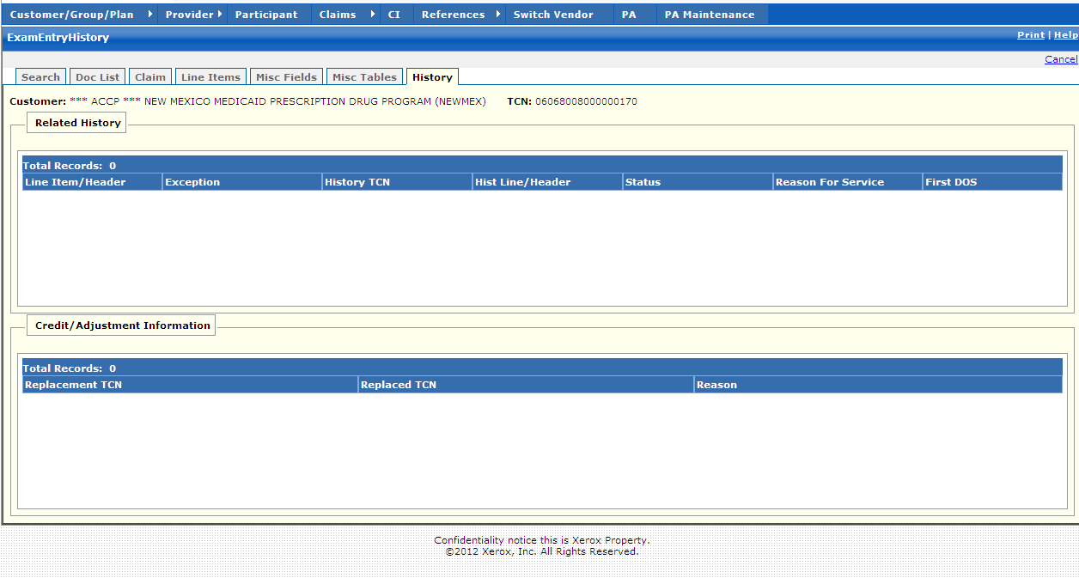

New Mexico PDCS OS PLUS Claims Subsystem
Window Exhibit
Exam Entry Functional Group
History Window
Field Name | Table Column Name | Table Name | Format | Prot. (A,C,N) | Req.  (A,C,N) | Std. Edits | Specifications | Note  Ref.
Customer | R-CUST-PART-NUM | B_DETAIL_NM | 9,999 | A | N/A | N/A | Display Header
TCN | C_TCN_NUM | C_LI_DRUG_TB | X(17) | A | N/A | N/A | Displays the Transaction control number of particular claim.
Related History | N/A | N/A | N/A | N/A | N/A | N/A | Grouping
Line Item/Header | C_LI_NUM | C_HDR_RLTD_HIST_TB | X(4) | A | N | N/A
Exception | R_CLM_EXC_CD | C_HDR_RLTD_HIST_TB | X(4) | A | N | N/A
History TCN | C_RLTD_LI_TCN_NUM | C_HDR_RLTD_HIST_TB | X(17) | A | N | N/A
Hist Line/Header | C_RLTD_LI_NUM | C_HDR_RLTD_HIST_TB | X(2) | A | N | N/A
Status | C_EXC_STAT_CD | C_HDR_RLTD_HIST_TB | X(1) | A | N | N/A | Valid Value 4200
Reason for Service | R_RSN_FOR_SVC_CD | C_HDR_RLTD_HIST_TB | X(2) | A | N | N/A | Valid Value 8605
First DOS | C_HDR_SVC_FST_DT | C_LI_DRUG_TB | DATE | A | N | N/A | Format: MM/DD/CCYY
Total Records | N/A | N/A | Display | A | N/A | N/A | Computed as total number of records meeting the criteria
Credit/  Adjustment Information | N/A | N/A | N/A | N/A | N/A | N/A | Grouping
Replacement TCN | C_REPLCMT_TCN_NUM | C_HDR_ADJ_VD_TB | 9(17) | A | N | N/A
Replaced TCN | C_REPLCD_TCN_NUM | C_HDR_ADJ_VD_TB | 9(17) | A | N | N.A
Reason | C_HDR_ADJ_RSN_CD | C_HDR_ADJ_VD_TB | X(3) | A | N | N/A | Valid Value 0961
Total Records | N/A | N/A | Display | A | N | N/A | Computed as total number of records meeting the criteria

Legend
Prot. and Req. | Standard Edits | Note Ref.
A = Always | D = Date Edit | C = Customer-specific field or functionality
C = Conditionally | N = Numeric Edits | R = Note Reference
N = Never | S = System Generated
 | V = Valid Value Edit

Ref. No. | Notes
N/A | N/A

13.2.6.4 Adjustment Functional Group

This functional group provides the user the ability to:

- Locate the adjustment Batch Control record
- Search for the claim to be adjusted
- Correct the claim information
- Adjudicate the adjustment claim

The following tab windows are used by the Adjustment Functional Group:

- Adjustment Batch Search
- Adjustment Information
- Doc List
- Claim
- Line Items
- Misc. Fields
- Misc. Tables
- History
- Overrides

The following data is displayed in the title bar of all tab windows (i.e., not on search windows) in this functional group:

- Customer name and TCN

New Mexico PDCS OS PLUS Claims Subsystem
Window Specification
Adjustment Functional Group
Adjustment Batch Search Window

Window Name: Adjustment: Adjustment Batch Search
Description:
The Adjustment Batch Search window allows the user to enter selection criteria to locate the Batch Control record related to a batch of adjustments to be exam entered. The Batch Date is required. The Batch number field can be used to refine the search. Information for all adjustment batches with the specified Batch Date is displayed in the list box.

All batch control records with Batch Type “Y” and Document Type “A” (Adjustments) are displayed here.

Window Type:
Response Window

Navigation:
The user enters this window by selecting the Adjustment option from the Claims subsystem menu. The user must click on the Batch key to proceed to the Adjustment Information window where the user enters the TCN of the original claim to be adjusted. The TCN or the “Provider ID”, Provider ID Type”, “Rx #” and “Date Filled” are required on the Adjustment Information Window. After all required information has been entered, the user selects the ADJUST button to open the Exam Entry window to update the claim data.

Interface to Other Subsystem(s):
N/A

Interface to Other Application(s):
N/A

Special Security Requirements:
N/A

Presentation Sequence(s):
The system displays the data sorted by Batch Key in ascending order.

Remarks:
N/A

New Mexico PDCS OS PLUS Claims Subsystem
Window Layout
Adjustment Functional Group
Adjustment Batch Search Window

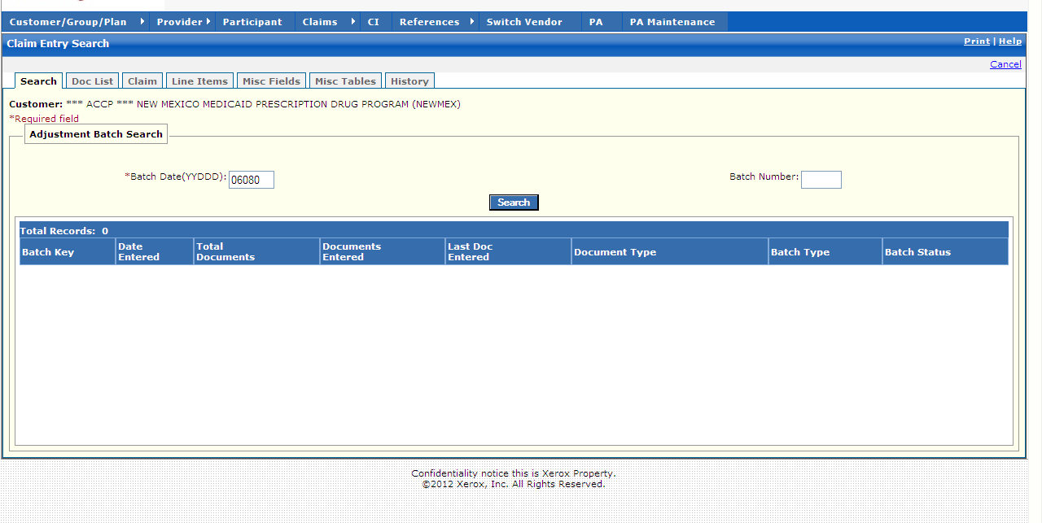

New Mexico PDCS OS PLUS Claims Subsystem
Window Exhibit
Adjustment Functional Group
Adjustment Batch Search Window
Field Name | Table Column Name | Table Name | Format | Prot. (A,C,N) | Req.  (A,C,N) | Std. Edits | Specifications | Note  Ref.
Customer | R-CUST-PART-NUM | B_DETAIL_NM | 9,999 | A | N/A | N/A | Display Header
Adjustment Batch Search Entry | N/A | N/A | N/A | N/A | N/A | N/A | Grouping
Batch Date | C_BAT_JLN_DT_NUM | C_BAT_CNTL_TB | X(5) | N | A | D | Format (YYDDD)  Must be a valid date
Batch Number | C_BAT_NUM | C_BAT_CNTL_TB | X(4) | N | N | N | Must be 4 digits
Command Button | Group | N/A | Button Row | N/A | N/A | N/A | Grouping
Search | N/A | N/A | Push Button | N | N | N/A | When pressed, batches meeting the Search Criteria entered by the user are displayed in the list box.
Adjustment Batch Search Display | Group | N/A | Group | N/A | N/A | N/A | Grouping
Batch Key | C_BAT_MED_SRC_CD  C_BAT_JLN_DT_NUM  C_BAT_NUM | C_BAT_CNTL_TB | X(1)  X(5)  X(4) | A | N | N/A | Valid Value 0142 Concatenation of Medium Indicator, Batch Date and Batch Number
Date Entered | C_BAT_ENTRY_DT | C_BAT_CNTL_TB | DATE | A | N | N/A | Format: MM/DD/CCYY
Total Documents | C_BAT_DOC_CNT_NUM | C_BAT_CNTL_TB | X(9) | A | N | N/A
Documents Entered | C_DOC_ENTR_CNT_NUM | C_BAT_CNTL_TB | X(9) | A | N | N/A
Last Doc Entered | C_LAST_ENTRD_NUM | C_BAT_CNTL_TB | X(9) | A | N | N/A
Document Type | C_BAT_DOC_TY_CD | C_BAT_CNTL_TB | X(1) | A | N | N/A | Valid Value 0161
Batch Type | C_BAT_TY_CD | C_BAT_CNTL_TB | X(1) | A | N | N/A | Valid Value 0140
Batch Status | C_BAT_STAT_CD | C_BAT_CNTL_TB | X(1) | A | N | N/A | Valid Value 0122
Total Records | N/A | N/A | Display | A | N | N/A | Computed as total number of records meeting the search criteria

Legend
Prot. and Req. | Standard Edits | Note Ref.
A = Always | D = Date Edit | C = Customer-specific field or functionality
C = Conditionally | N = Numeric Edits | R = Note Reference
N = Never | S = System Generated
 | V = Valid Value Edit

Ref. No. | Notes
N/A | N/A
New Mexico PDCS OS PLUS Claims Subsystem
Window Specification
Adjustment Functional Group
Adjustment Information Window

Window Name: Adjustment: Adjustment Information
Description:
The Adjustment Information window is presented to authorized users to correct a previously submitted claim.

The Adjustment Information Window opens with a new system-generated TCN for the adjustment claim. The user may enter either the TCN of the original claim to be adjusted OR the Provider ID, Provider ID Type, Rx #, and Date Filled. The Group ID and Adjustment Reason Code are also required.

When the original claim is located, the Claim Window displays the information submitted on the original claim. The system generates a new TCN for the adjusted claim. The user corrects the claim as needed, verifies it, and submits the adjustment claim for adjudication. A credit claim is automatically created to reverse the original claim. After adjudication, the original TCN appears on the History tab of the adjusted claim in Claim Inquiry.

Window Type:
Response Window

Navigation:
The user enters this window by selecting the batch key from the Adjustment Batch Search window. After entering all the required information to locate the claim to be adjusted, the user selects the ADJUST button to enter the Adjustment Information Windows.

Interface to Other Subsystem(s):
N/A

Interface to Other Application(s):
N/A

Special Security Requirements:
Access to data is controlled by the user’s security profile.

Presentation Sequence(s):
N/A

Remarks:
Refer to the Exam Entry Functional Group for the description of the Exam Entry tab pages.

New Mexico PDCS OS PLUS Claims Subsystem
Window Layout
Adjustment Functional Group
Adjustment Information Window

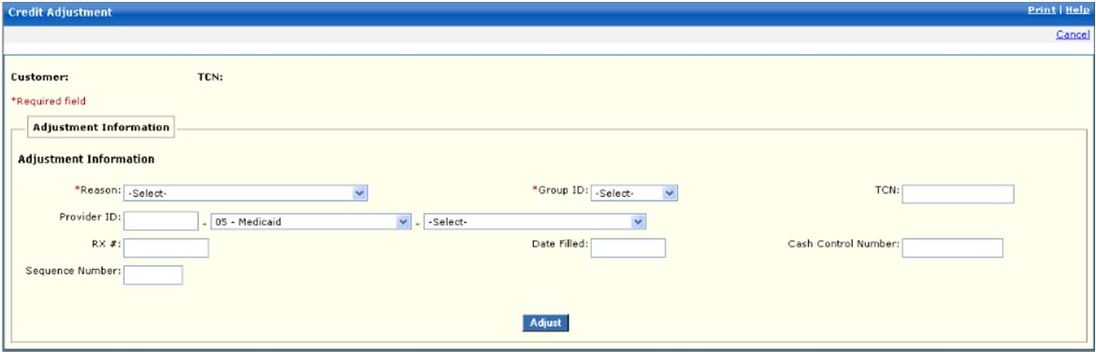

New Mexico PDCS OS PLUS Claims Subsystem
Window Exhibit
Adjustment Functional Group
Adjustment Information Window
Field Name | Table Column Name | Table Name | Format | Prot. (A,C,N) | Req.  (A,C,N) | Std. Edits | Specifications | Note  Ref.
Customer | R-CUST-PART-NUM | B_DETAIL_NM | 9,999 | A | N/A | N/A | Display Header
TCN | C_TCN_NUM | C_LI_DRUG_TB | X(17) | A | N/A | N/A | Displays the Transaction control number of particular claim.
Adjustment Information | N/A | N/A | N/A | N/A | N/A | N/A | Grouping
Reason | C_HDR_ADJ_RSN_CD | C_HDR_ADJ_VD_TB | Drop-down | N | A | V | Valid Values List 0961
Provider ID  Provider ID Type  (unlabeled)  Provider ID Source  (unlabeled) | P_ALT_ID  P_ALT_ID_CD  P_ALT_ID_TY_CD | C_ALT_IX_RX_NUM_TB | X(15)  Drop-down  Drop-down | N  N  N | C  N  N | N  V  V | If entered, must be same pharmacy as Original Claim.  Valid Value 0204  Valid Value 0486 | R1
RX # | C_RX_SVC_REF_NUM | C_LI_DRUG_TB | X(12) | N | C | N | If entered, value must match Original Claim value. | R1
Sequence Number | C_ADJ_SEQ_NUM | C_HDR_ADJ_VD_TB | 9(4) | N | C | N
Group ID | R_GROUP_ID | C_LI_DRUG_TB | Drop-down | N | A | N/A | Defaults to the customers specific group
Date Filled | C_HDR_SVC_FST_DT | C_LI_DRUG_TB | DATE | N | C | D | Format: MM/DD/CCYY  If entered, value must match Original Claim value.  Must be a valid date | R1
TCN | C_TCN_NUM | C_LI_DRUG_TB | X(17) | N | C | N | If entered, value must match Original Claim value. | R1
Cash Control Number | C_CUST_FCN_NUM | C_HDR_ADJ_VD_TB | X(20) | N | C | N
Command Button | Group | N/A | Button Row | N/A | N/A | N/A | Grouping
Adjust | N/A | N/A | Push Button | N | N | N/A | When the Adjust Button is selected, the system locates the original claim and populates the fields on the adjustment claim. Appropriate changes are made and the adjustment claim submitted.

Legend
Prot. and Req. | Standard Edits | Note Ref.
A = Always | D = Date Edit | C = Customer-specific field or functionality
C = Conditionally | N = Numeric Edits | R = Note Reference
N = Never | S = System Generated
 | V = Valid Value Edit

Ref. No. | Notes
R1 | The user can enter the TCN of the original claim or the Provider ID, Provider Type, Rx, and Date Filled to find the matching original claim.
New Mexico PDCS OS PLUS Claims Subsystem
Window Specification
Adjustment Functional Group
Documents Window

Window Name: Adjustment: Documents
Description:
The Exam Entry Documents Window allows for the display of additional claims for the participant within the batch selected. This tab only appears during Exam Entry, Claims Adjustment, and Claims Credit.

Window Type:
Response Window

Navigation:
The user enters this window by clicking on the Doc List tab.

Interface to Other Subsystem(s):
N/A

Interface to Other Application(s):
N/A

Special Security Requirements:
Access to data is controlled by the user’s security profile.

Presentation Sequence(s):
The records are sorted by document number.

Remarks:
N/A

New Mexico PDCS OS PLUS Claims Subsystem
Window Layout
Adjustment Functional Group
Documents Window

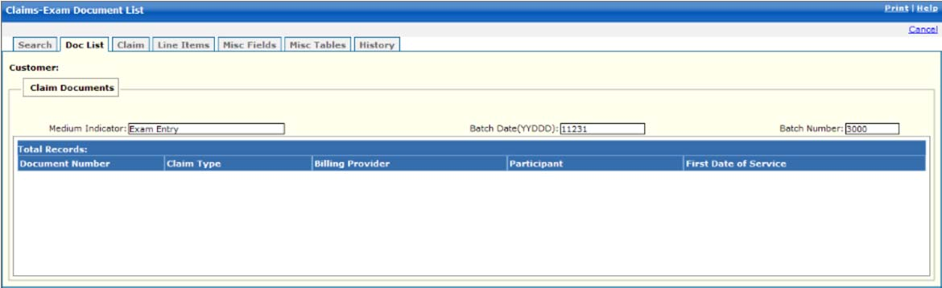

New Mexico PDCS OS PLUS Claims Subsystem
Window Exhibit
Adjustment Functional Group
Documents Window
Field Name | Table Column Name | Table Name | Format | Prot. (A,C,N) | Req.  (A,C,N) | Std. Edits | Specifications | Note  Ref.
Customer | R-CUST-PART-NUM | B_DETAIL_NM | 9,999 | A | N/A | N/A | Display Header
Claim Documents Entry | N/A | N/A | N/A | N/A | N/A | N/A | Grouping
Medium Indicator | C_BAT_ MED_SRC_CD | C_BAT_CNTL_TB | X(1) | A | N | N/A | Valid Value 142 | R1
Batch Date | C__BAT_JLN_DT_NUM | C_BAT_CNTL_TB | X(5) | A | N | N/A | Format: YYDDD | R1
Batch Number | C_BAT_NUM | C_BAT_CNTL_TB | X(4) | A | N | N/A | Must be 4 digits | R1
Claim Documents Display | Group | N/A | Group | N/A | N/A | N/A | Grouping
Document Number | C_HDR_DOC_NUM | C_BAT_CNTL_TB | X (6) | A | N | N/A
Claim Type | C_BAT_TY_CD | C_BAT_CNTL_TB | X (1) | A | N | N/A | Valid Value 0140
Billing Provider | P_SVC_PHARM_ALT_ID | C_LI_DRUG_TB | X(15) | A | N | N/A
Participant | B_CRDHLDR_ALT_ID | C_LI_DRUG_TB | X(20) | A | N | N/A
First Date of Service | C_HDR_SVC_FST_DT | C_LI_DRUG_TB | DATE | A | N | N/A | Format: MM/DD/CCYY
Total Records | N/A | N/A | Display | A | N | N/A | Computed as total number of records meeting the search criteria

Legend
Prot. and Req. | Standard Edits | Note Ref.
A = Always | D = Date Edit | C = Customer-specific field or functionality
C = Conditionally | N = Numeric Edits | R = Note Reference
N = Never | S = System Generated
 | V = Valid Value Edit

Ref. No. | Notes
R1 | This field is prepopulated from Exam Entry, Adjustment, or Credit batch information.
New Mexico PDCS OS PLUS Claims Subsystem
Window Specification
Adjustment Functional Group
Claim Adjustment Window

Window Name: Adjustment: Claim Adjustment
Description:
The Claim Adjustment Window is presented to authorize users to adjust pharmacy claim data. This window opens with a system-generated TCN allowing the user to adjust a claim and prepopulated data from the original claim.

The Participant pane contains fields to allow entry of Participant information. Minimum Participant fields required to enter a Claim are Social Security Number with an ID Type of 97 – Client Specific ID.

The Provider pane allows entry of the Pharmacy ID and Prescriber ID. Minimum Provider fields required to enter a Claim are NCPDP of the dispensing pharmacy with an ID Type of 07 – NCPDP Provider Type and the DEA Number of the prescribing physician

The COB pane allows for entry of Coordination of Benefits indicator. COB indicator is not a required field.

The Rx Information pane allows entry of Prescription or Service information. Minimum Rx Information fields required to enter a Claim are Rx/Service #, Submit Days, Submit Qty, Drug NDC #, Date Written, Date Filled and Qty Prescribed

The Pricing Pane allows entry of Pricing information. Minimum Pricing fields required to enter a Claim are Submit Ingredient Cost and Total Charge.

The Other Information pane allows entry of Override information.

Window Type:
Response Window

Navigation:
The user enters this window by selecting “Adjust” from the Adjustment Information page.

After entering a claim, the user may select one of the following options:
CONTINUE – If submitting a multi-line compound, click “Continue” to move to additional data entry windows.
SAVE – the record is saved and the Claims tab remains open for entry on the next claim.
VERIFY – the record is saved; Edits appears for correction; the claim can be submitted for processing.
SUBMIT – the record is saved, the claim is processed and added to the database; the claim is available for viewing in Claims Inquiry

Interface to Other Subsystem(s):
Adjudication happens here – Interfaces to all PDCS OS PLUS subsystems such as Participant, Provider, and Reference.

Interface to Other Application(s):
MMIS Reference for Diagnosis information

Special Security Requirements:
Access to data is controlled by the user’s security profile.

Presentation Sequence for Exceptions:
Line Item number, Exception Number

Remarks:
N/A

New Mexico PDCS OS PLUS Claims Subsystem
Window Layout
Adjustment Functional Group
Claim Adjustment Window

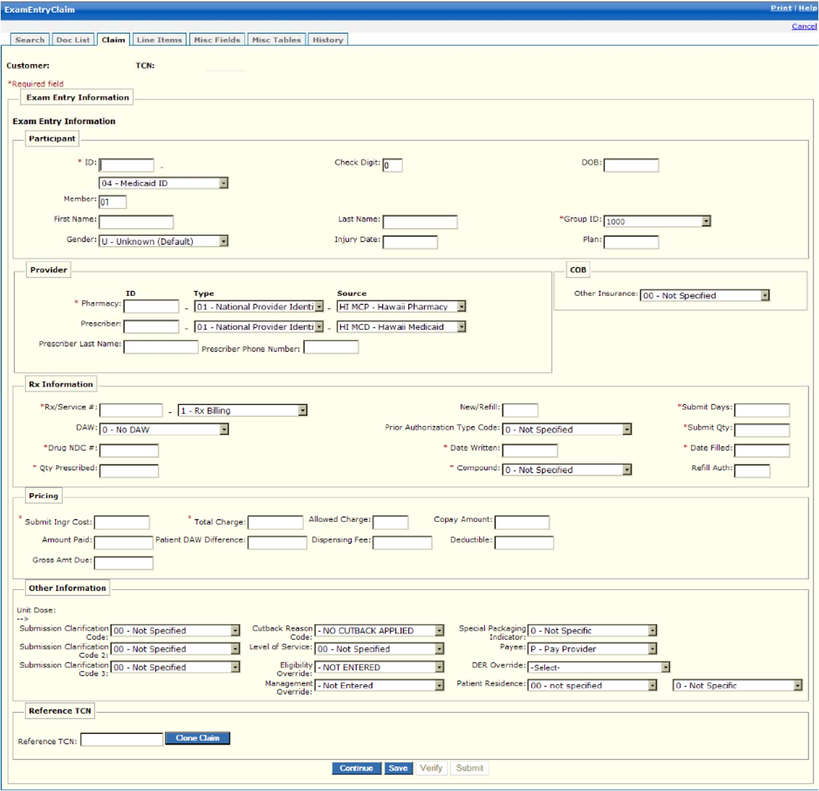

Note: Some screen shots within this and other sections containing participant data have been made using test IDs devoid of PHI.
In other cases, real data with PHI masked has been used to demonstrate important New Mexico functions .

New Mexico PDCS OS PLUS Claims Subsystem
Window Exhibit
Adjustment Functional Group
Claim Adjustment Window
Field Name | Table Column Name | Table Name | Format | Prot. (A,C,N) | Req.  (A,C,N) | Std. Edits | Specifications | Note  Ref.
Customer | R-CUST-PART-NUM | B_DETAIL_NM | 9,999 | A | N/A | N/A | Display Header
TCN | C_TCN_NUM | C_LI_DRUG_TB | X(17) | A | N/A | N/A | Displays the Transaction control number of particular claim.
Exam Entry Information | N/A | N/A | N/A | N/A | N/A | N/A | Grouping
Participant | N/A | N/A | N/A | N/A | N/A | N/A | Grouping
ID | B_CRDHLDR_ALT_ID  B_CRDHLD_ALT_ID_CD | C_LI_DRUG_TB | X(20)  Drop-down | N  N | A  A | N  V | Valid Value 0255
First Name | B_FST_NAM | C_HDR_TB | X(30) | N | C | N/A
Gender | B_GENDER_CD | C_HDR_TB | Drop-down | N | N | V | Valid Value 0229
Check Digit | B-CHK_DIG_NUM | C_HDR_TB | Small Integer | N | N | N/A
Last Name | B_LST_NAM | C_HDR_TB | X(35) | N | C | N/A
Injury Date | C-HDR-INJURY-DT | C-HDR-TB | DATE | N | C | D | Must be a valid date
Member | B-MBR-NUM | C_LI_DRUG_TB | X(4) | N | C | N/A
DOB | B_DOB_DT | C_HDR_TB | DATE | N | C | D | Format: MM/DD/CCYY
Group ID | R_GROUP_ID | C_LI_DRUG_TB | Drop-down | N | N | N/A
Plan | R_PLAN_ID | C_LI_DRUG_TB | X(3) | N | C | N/A
Provider | Group | N/A | Group | N/A | N/A | N/A | Grouping
Pharmacy ID | P_SVC_PHARM_ALT_ID | C_LI_DRUG_TB | X(15) | N | A | N
Pharmacy Type | P_SVC_PH_ALT_ID_CD | C_LI_DRUG_TB | Drop-down | N | A | V | Valid Value 4844
Pharmacy Source | P_SPH_ALT_ID_TY_CD | C_LI_DRUG_TB | Drop-down | N | A | V | Valid Value 0526
Prescriber ID | P_PRSC_ALT_ID | C_LI_DRUG_TB | X(15) | N | A | N
Prescriber Type | P_PRSC_ALT_ID_CD | C_LI_DRUG_TB | Drop-down | N | A | V | Valid Value 2693
Prescriber Source | P_PRS_ALT_ID_TY_CD | C_LI_DRUG_TB | Drop-down | N | A | V | Valid Value 5319
COB | NA | N/A | N/A
Other Insurance | C_OTHR_INS_IND | C_HDR_TB | Drop-down | N | N | V | Defaults to 00  Valid Value 3078
Rx Information | N/A | N/A | N/A | N/A | N/A | N/A | Grouping
Rx/Service # | C_RX_SVC_REF_NUM  C_RX_SVC_REF_CD | C_LI_DRUG_TB | 9(12) | N  N | A  A | N  V | Defaults to 01-Rx Billing  Valid Values 9049
DAW | C_DAW_CD | C_HDR_DRUG_TB | Drop-down | N | N | V | Valid Values 0246. Defaults to 0
Drug NDC # | R_DRUG_CD | C_LI_DRUG_TB | X(11) | A | N | N/A
Qty Prescribed | C_QTY_PRSC_AMT | C_HDR_DRUG_TB | X(7) | N | A | N
New/Refill | C_RX_REFILL_NUM | C_HDR_DRUG_TB | X(2) | N | N | N
Prior Authorization Type Code | C_PA_TY_CD | C_LI_DRUG_TB | Drop-down | N | N | V | Valid Value 0596
Date Written | C_DRUG_PRESCR_DT | C_LI_DRUG_TB | DATE | N | A | D | Format: MM/DD/CCYY  Must be a valid date
Compound | C_DRUG_CMPND_CD | C_LI_DRUG_TB | Drop-down | N | A | V | Valid Values 0824.
Submit Days | C_SUB_DAY_SPLY_AMT | C_LI_DRUG_TB | X(3) | N | A | N
Submit Qty | C_SUBM_ING_QTY_AMT | C_LI_DRUG_TB | X(8) | N | A | N
Date Filled | C_HDR_SVC_FST_DT | C_LI_DRUG_TB | DATE | N | A | D | Format: MM/DD/CCYY  Must be a valid date
Refill Auth | C_REFIL_AUTH_NUM | C_HDR_DRUG_TB | X(2) | N | N | N
Pricing | N/A | N/A | N/A | N/A | N/A | N/A | Grouping
Submit Ingr Cost | C_SUBM_INGRED_CST_AMT | C_LI_DRUG_TB | X(7) | N | A | N
Amount Paid | C_LI_REIMB_AMT | C_LI_DRUG_TB | X(7) | N | C | N
Gross Amount Due | C_DRUG_GROSS_AMT | C_HDR_DRUG_TB | X(5)v99 | N | C | N
Total Charge | C_TOT_CHRG_AMT | C_LI_DRUG_TB | X(9)V99 | N | A | N
Patient DAW Difference | C_PAT_DAW_DIF_AMT | C_HDR_DRUG_TB | X(9)V99 | N | C | N
Allowed Charge | C_CALC_ALLOW_AMT | C_LI_DRUG_TB | X(9)V99 | N | C | N
Dispensing Fee | C_DISP_FEE_AMT | C_LI_DRUG_TB | X(9)V99 | N | C | N
Copay Amount | C_TOT_COPAY_AMT | C_LI_DRUG_TB | X(9)V99 | N | C | N
Deductible | C_HDR_DRUG_DED_AMT | C_LI_DRUG_TB | X(9)V99 | N | C | N
Other Information | N/A | N/A | N/A | N/A | N/A | N/A | Grouping
Submission Clarification Code | C_DRUG_RX_OVRRD_CD | C_LI_DRUG_TB | Drop-down | N | N | V | Valid Values 0874
Cutback Reason Code | C_CTBCK_RSN_CD | C_LI_DRUG_TB | Drop-down | N | N | V | Valid Values 5426
Level of Service | C_LVL_OF_SVC_CD | C_HDR_DRUG_TB | Drop-down | N | N | V | Valid Values 4468
Eligibility Override | C_ELIG_OVRRD_IND | C_HDR_DRUG_TB | Drop-down | N | N | V | Valid Values 0882
Patient Location | C_PAT_LOC_CD | C_HDR_TB | Drop-down | N | N | V | Valid Values 5668
Unit Dose | C_UNIT_DOSE_CD | C_HDR_DRUG_TB | Drop-down | N | N | V | Valid Values 3575
Management Override | C_MGMT_OVRRD_IND | C_HDR_DRUG_TB | Drop-down | N | N | V | Valid Values 1112
Payee | C_DRUG_PAYEE_CD | C_HDR_DRUG_TB | Drop-down | N | N | V | Valid Values 0857
DER Override | C_DER_OVRRD_CD | C_LI_DRUG_TB | Drop-down | N | N | V | Valid Values 6987
Command Buttons | Group | N/A | Button Row | N/A | N/A | N/A | Grouping
Continue | N/A | N/A | Press Button | N | N | N/A | When pressed, claim is saved and the Line Items page is opened to enter information for compound drugs.
Save | N/A | N/A | Press Button | N | N | N/A | When pressed, the claim is saved and the Exam Entry window remains open to enter the next Claim.
Verify | N/A | N/A | Press Button | N | N | N/A | When pressed, the claim is saved and edits appear for correction, if appropriate. The claim can be submitted for processing.
Submit | N/A | N/A | Press Button | N | N | N/A | When pressed, the claim is saved, processed, and added to the database. The claim is available for viewing in Claims Inquiry.

Legend
Prot. and Req. | Standard Edits | Note Ref.
A = Always | D = Date Edit | C = Customer-specific field or functionality
C = Conditionally | N = Numeric Edits | R = Note Reference
N = Never | S = System Generated
 | V = Valid Value Edit

Ref. No. | Notes
N/A | N/A
New Mexico PDCS OS PLUS Claims Subsystem
Window Specification
Adjustment Functional Group
Line Items Window

Window Name: Adjustment: Line Items
Description:
The Line Items Window is presented to authorized users to enter/edit pharmacy claim line item data for compound drugs.

If the claim is for a compound drug, each ingredient is entered using this window. If the claim is for a single-ingredient drug, only one record appears.

Information such as Ingredient Drug Cost, Ingredient Cost, and Drug NDC Number is specified and if adding a line item, these fields are required.

Lines can be added, updated, or deleted.

Window Type:
Response Window

Navigation:
The user enters this window by clicking on the Exam Entry tab while in the Claims subsystem. The user selects the Line Items tab. Exam Entry Line Items Window can also be accessed if the user chooses to CONTINUE for compound drug processing from the Exam Entry Claim Window.

Interface to Other Subsystem(s):
PDCS OS PLUS Reference to validate NDC

Interface to Other Application(s):
N/A

Special Security Requirements:
Access to data is controlled by the user’s security profile.

Remarks:
Delete option requires a confirmation.

New Mexico PDCS OS PLUS Claims Subsystem
Window Layout
Adjustment Functional Group
Line Items Window

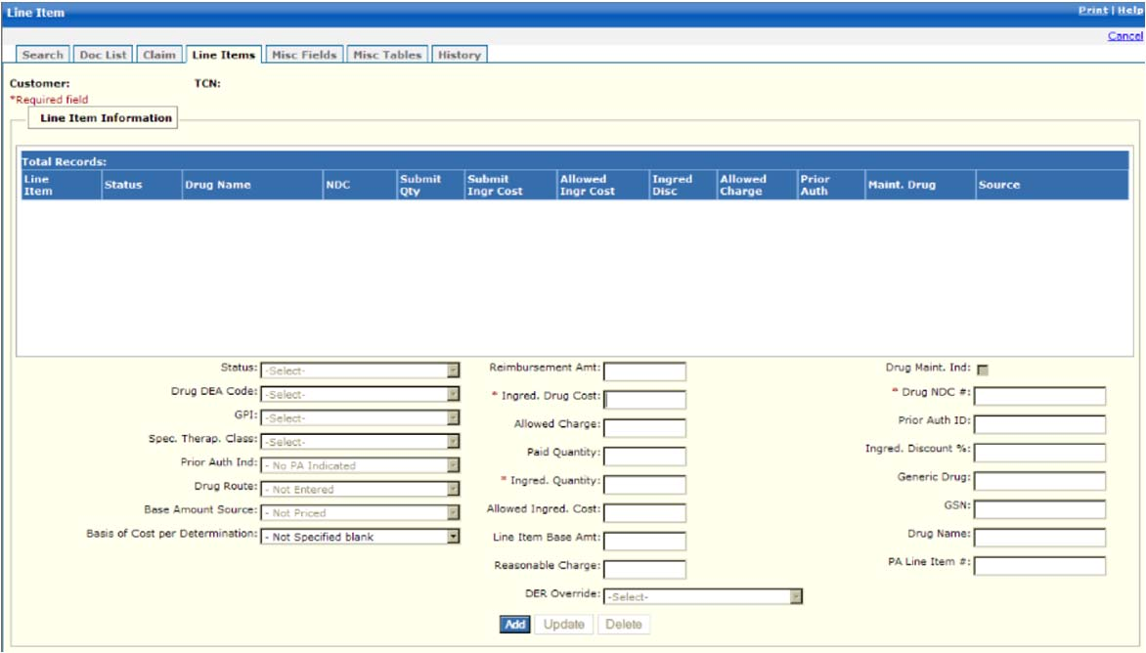

New Mexico PDCS OS PLUS Claims Subsystem
Window Exhibit
Adjustment Functional Group
Line Items Window
Field Name | Table Column Name | Table Name | Format | Prot. (A,C,N) | Req.  (A,C,N) | Std. Edits | Specifications | Note  Ref.
Customer | R-CUST-PART-NUM | B_DETAIL_NM | 9,999 | A | N/A | N/A | Display Header
TCN | C_TCN_NUM | C_LI_DRUG_TB | X(17) | A | N/A | N/A | Displays the Transaction control number of particular claim.
Line Item Information Display | N/A | N/A | N/A | N/A | N/A | N/A | Grouping
Line Item | C_LI_NUM | C_LI_DRUG_TB | X(2) | A | N
Status | C_REIMB_STAT_CD | C_LI_DRUG_TB | X(1) | A | N | N/A | Valid Value 0162
Drug Name | R_DRUG_NAM | C_LI_DRUG_TB | X(30) | A | N | N/A
NDC | R_DRUG_CD | C_LI_DRUG_TB | X(11) | A | N | N/A
Submit Qty | C_SUBM_ING_QTY_AMT | C_LI_DRUG_TB | X(8)v9  (3) | A | N | N/A
Submit Ingr  Cost | C_SUBM_ING_CST_AMT | C_LI_DRUG_TB | X(7)v9  (2) | A | N | N/A
Allowed Ingr Cost | C_LI_ING_ALLOW_AMT | C_LI_DRUG_TB | X(9)v9  (2) | A | N | N/A
Ingred Disc | C_INGRED_DISCT_PCT | C_LI_DRUG_TB | X(3)v9  (2) | A | N | N/A
Allowed Charge | C_CALC_ALLOW_AMT | C_LI_DRUG_TB | X(9)v9  (2) | A | N | N/A
Prior Auth | A_ID | C_LI_DRUG_TB | X(11) | A | N | N/A
Maint. Drug | C_DRUG_MAINT_IND | C_LI_DRUG_TB | X(1) | A | N | N/A | Valid Value 0848
Source | C_BSE_AMT_SRC_CD | C_LI_DRUG_TB | X(2) | A | N | N/A | Valid Value 0167
Total Records | N/A | N/A | Display | A | N | N/A | Computed as total number of records meeting the search criteria
Status | C_REIMB_STAT_CD | C_LI_DRUG_TB | Drop-down | N | N | V | Valid Values List 0162
Drug DEA Code | C_DRUG_DEA_CD | C_LI_DRUG_TB | Drop-down | N | N | V | Valid Values List 0314
GPI | R_DRUG_GEN_PRD_CD | C_LI_DRUG_TB | Drop-down | N | N | V | Valid Values List 1839
Spec. Therap. Class | R_DRG_THR_CHAR3_CD | C_LI_DRUG_TB | Drop-down | N | N | V | Valid Values List 1804
Prior Auth Ind | C_PRIOR_AUTH_IND | C_LI_DRUG_TB | Drop-down | N | N | V | Valid Values List 1142
Drug Route | C_DRUG_ROUTE_CD | C_LI_DRUG_TB | Drop-down | N | N | V | Valid Values List 0872
Base Amount Source | C_BSE_AMT_SRC_CD | C_LI_DRUG_TB | Drop-down | N | N | V | Valid Values List 0167
Basis of Cost per Determination | C_BASIS_COST_CD | C_LI_DRUG_TB | Drop-down | N | N | V | Valid Values List 9136
Reimbursement Amt | C_LI_REIMB_AMT | C_LI_DRUG_TB | X(7)v99 | N | N | N
Ingred Drug Cost | C_SUBM_ING_CST_AMT | C_LI_DRUG_TB | X(7)v99 | N | A | N
Allowed Charge | C_CALC_ALLOW_AMT | C_LI_DRUG_TB | X(9)v99 | N | N | N
Paid Quantity | C_LI_PD_QTY_AMT | C_LI_DRUG_TB | X(8)v999 | N | N | N
Ingred. Quantity | C_SUBM_ING_QTY_AMT | C_LI_DRUG_TB | X(8)v999 | N | A | N
Allowed Ingred. Cost | C_LI_ING_ALLOW_AMT | C_LI_DRUG_TB | X(7)v99 | N | N | N
Line Item Base Amt | C_LI_BSE_AMT | C_LI_DRUG_TB | X(7)v99 | N | N | N
Reasonable Charge | C_DRUG_GROSS_AMT | C_HDR_DRUG_TB | X(5)v99 | N | N | N
DER Override | C_DER_OVRRD_CD | C_LI_DRUG_TB | X(2) | N | N | V | Valid Values List 6987
Drug Maint Ind | C_DRUG_MAINT_IND | C_LI_DRUG_TB | Check Box | N | N | V | Valid Value 0848
Drug NDC # | R_DRUG_CD | C_LI_DRUG_TB | X(11) | A | N | N/A
Prior Auth ID | A_ID | C_LI_DRUG_TB | X(11) | N | N | N
Ingred Discount % | C_INGRED_DISCT_PCT | C_LI_DRUG_TB | X(3)v9  (2) | N | N | N
Generic Drug | C_DRUG_GEN_CD_NUM | C_LI_DRUG_TB | X(5) | N | N | N
GSN | R_DRUG_GCN_SEQ_NUM | C_LI_DRUG_TB | X(6) | N | N | N
Drug Name | R_DRUG_NAM | C_LI_DRUG_TB | X(30) | N | N | N
PA Line Item | A_LI_NUM | C_LI_DRUG_TB | X(4) | N | N | N
Command Buttons | Group | N/A | Button Row | N/A | N/A | N/A | Grouping
Add | N/A | N/A | Push Button | N | N | N/A
Update | N/A | N/A | Push Button | N | N | N/A
Delete | N/A | N/A | Push Button | N | N | N/A

Legend
Prot. and Req. | Standard Edits | Note Ref.
A = Always | D = Date Edit | C = Customer-specific field or functionality
C = Conditionally | N = Numeric Edits | R = Note Reference
N = Never | S = System Generated
 | V = Valid Value Edit

Ref. No. | Notes
N/A | N/A
New Mexico PDCS OS PLUS Claims Subsystem
Window Specification
Adjustment Functional Group
Miscellaneous Fields Window

Window Name: Adjustment: Miscellaneous Fields
Description:
Authorized users utilize the Adjustment Miscellaneous Fields Window to enter/edit claim information associated with partial and completion fill claims and other miscellaneous NCPDP 5.1 information.

Window Type:
Response Window

Navigation:
The user enters this window by selecting the Misc. Fields tab.

Interface to Other Subsystem(s):
PDCS OS PLUS Provider to validate Provider

Interface to Other Application(s):
N/A

Special Security Requirements:
Access to data is controlled by the user’s security profile.

Remarks:
N/A

New Mexico PDCS OS PLUS Claims Subsystem
Window Layout
Adjustment Functional Group
Miscellaneous Fields Window

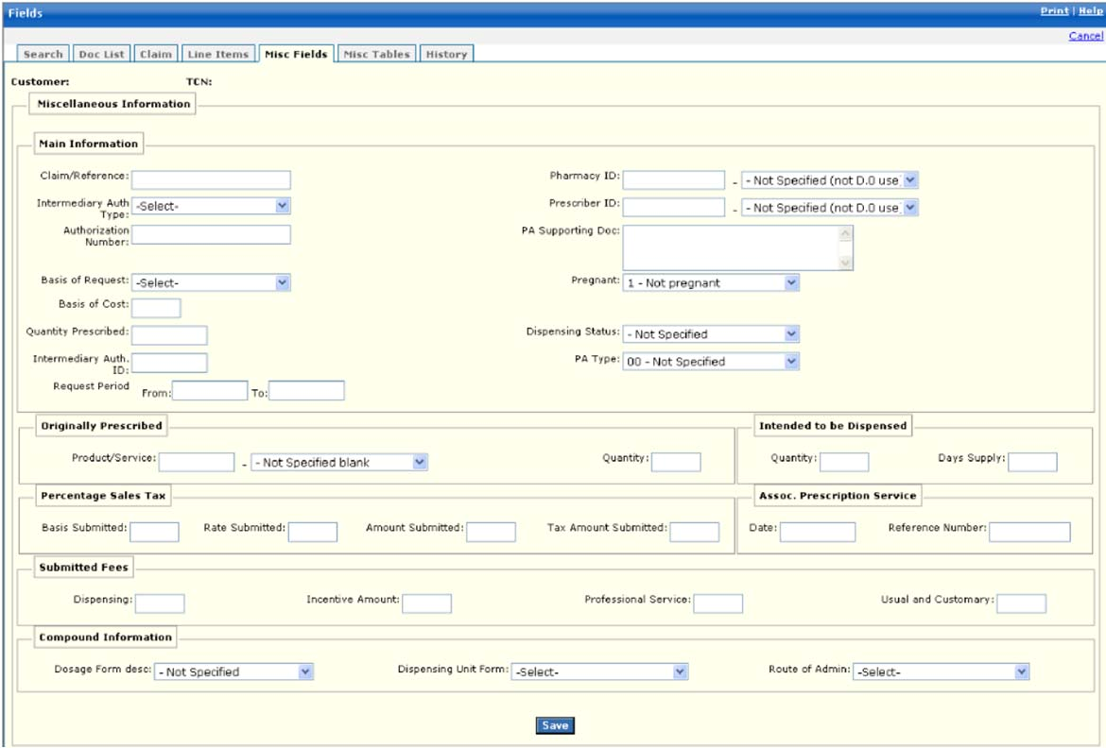

New Mexico PDCS OS PLUS Claims Subsystem
Window Exhibit
Adjustment Functional Group
Micellaneous Fields Window
Field Name | Table Column Name | Table Name | Format | Prot. (A,C,N) | Req.  (A,C,N) | Std. Edits | Specifications | Note  Ref.
Customer | R-CUST-PART-NUM | B_DETAIL_NM | 9,999 | A | N/A | N/A | Display Header
TCN | C_TCN_NUM | C_LI_DRUG_TB | X(17) | A | N/A | N/A | Displays the Transaction control number of particular claim.
Miscellaneous Information | N/A | N/A | N/A | N/A | N/A | N/A | Grouping
Main Information | N/A | N/A | N/A | N/A | N/A | N/A | Grouping
Claim/Reference | C_CLM_REF_ID_NUM | C_HDR_TB | X(30) | N | C | N/A
Intermediary Auth Type | C_INTMDRY_AUTH_CD | C_HDR_TB | Drop-down | N | N | V | Valid Value 8642
Authorization Number | A_AUTH_NUM | C_HDR_TB | X(20) | N | C | N
Basis of Request | C_PA_BASIS_REQ_CD | C_HDR_TB | Drop-down | N | N | V | Valid Values 9032
Basis of Cost | C_BASIS_COST_CD | C_LI_DRUG_TB | X(2) | N | C | V | Valid Values 9136
Quantity Prescribed | C_QTY_PRSC_AMT | C_HDR_DRUG_TB | X(7)V99 | N | C | N
Intermediary Auth ID | C_INTMDRY_AUTH_ID | C_HDR_TB | X(11) | N | C | N/A | Intermediary Authorization
Request Period From | C_PA_REQ_BEG_DT | C_HDR_TB | DATE | N | C | D | Format: MM/DD/CCYY  Must be valid date
Request Period To | C_PA_REQ_END_DT | C_HDR_TB | DATE | N | C | D | Format: MM/DD/CCYY  Must be valid date
Pharmacy ID | P_PHARM_ALT_ID  P_PHARM_ALT_ID_CD | C_HDR_DRUG_TB | X(15)  Drop-down | N  N | C  N | N/A  V | Valid Values 6011
Prescriber ID | P_PRSC_ALT_ID  P_PRSC_ALT_ID_CD | C_LI_DRUG_TB | X(15)  Drop-down | N  N | C  N | N/A  V | Valid Values 2693
PA Supporting Doc | C_PA_SUP_DOC_TX | C_HDR_TB | List Box | N | N | N/A
Pregnant | C_PRGNCY_IND | C_HDR_TB | Drop-down | N | N | V | Valid Values 9269
Dispensing Status | C_DISP_STATUS_CD | C_LI_DRUG_TB | Drop-down | N | N | V | Valid Values 8723
PA Type | C_PA_TYP_CD | C_LI_DRUG_TB | Drop-down | N | N | V | Valid Values 0596
Originally Prescribed | N/A | N/A | N/A | N/A | N/A | N/A | Grouping
Product/Service | C_ORG_PROD_SVC_ID  C_ORG_PROD_SVC_CD | C_HDR_DRUG_TB | X(19)  Drop-down | N  N | C  N | N/A  V | Valid Values List 6580
Quantity | C_ORG_QTY_PRSC_AMT | C_HDR_DRUG_TB | X(7)V99 | N | C | N
Intended to be Dispensed | N/A | N/A | N/A | N/A | N/A | N/A | Grouping
Quantity | C_INT_DISP_QTY_AMT | C_HDR_DRUG_TB | X(7)V99 | N | C | N
Days Supply | C_INT_DISP_DAY_NUM | C_HDR_DRUG_TB | X(3) | N | C | N
Percentage Sales Tax | N/A | N/A | N/A | N/A | N/A | N/A | Grouping
Basis Submitted | C_SUBM_PCT_TX_CD | C_HDR_DRUG_TB | X(2) | N | C | V | Valid Values List 2890
Rate Submitted | C_SUBM_PCT_RT_AMT | C_HDR_DRUG_TB | X(3)V9999 | N | C | N
Amount Submitted | C_SUBM_PCT_TX_AMT | C_HDR_DRUG_TB | X(7)V99 | N | C | N
Tax Amount Submitted | C_SUBM_TAX_AMT | C_HDR_DRUG_TB | X(9)V2 | N | C | N
Assoc. Prescription Service | N/A | N/A | N/A | N/A | N/A | N/A | Grouping
Date | C_ASOC_RX_SVC_DT | C_HDR_DRUG_TB | DATE | N | C | D | Format: MM/DD/CCYY  Must be a valid date
Reference Number | C_ASOC_RX_SVC_NUM | C_HDR_DRUG_TB | X(7) | N | C | N
Submitted Fees | N/A | N/A | N/A | N/A | N/A | N/A | Grouping
Dispensing | C_SUBM_DSP_FEE_AMT | C_HDR_DRUG_TB | X(6)V99 | N | C | N
Incentive Amount | C_SUBM_INCNTVE_AMT | C_HDR_DRUG_TB | X(6)V99 | N | C | N
Professional Services | C_SUBM_PRO_FEE_AMT | C_HDR_DRUG_TB | X(6)V99 | N | C | N
Usual and Customary | C_UC_CHARGE_AMT | C_HDR_DRUG_TB | X(6)V99 | N | C | N
Compound Information | N/A | N/A | N/A | N/A | N/A | N/A | Grouping
Dosage Form desc | C_DSG_FM_DESC_CD | C_HDR_DRUG_TB | Drop-down | N | N | V | Valid Value 7054
Dispensing Unit Form | C_DISP_UNT_FM_CD | C_HDR_DRUG_TB | Drop-down | N | N | V | Valid Value 8811
Route of Admin | C_CLM_RT__ADMIN_CD | C_HDR_DRUG_TB | Drop-down | N | N | V | Valid Value 9532
Command Button | Group | N/A | Button Row | N/A | N/A | N/A | Grouping
Save | N/A | N/A | Push Button | N | N | N/A

Legend
Prot. and Req. | Standard Edits | Note Ref.
A = Always | D = Date Edit | C = Customer-specific field or functionality
C = Conditionally | N = Numeric Edits | R = Note Reference
N = Never | S = System Generated
 | V = Valid Value Edit

Ref. No. | Notes
N/A | N/A
New Mexico PDCS OS PLUS Claims Subsystem
Window Specification
Adjustment Functional Group
Miscellaneous Tables Window

Window Name: Adjustment: Miscellaneous Tables
Description:
Authorized users utilize the Adjustment Miscellaneous Tables window to enter/edit claim information for repeating segments.

The Miscellaneous Tables window contains information pertaining to DUR, Procedure Modifier codes associated with physician services, Other Amounts associated with additional costs incurred for a dispensed prescription or service, Clinical information, Diagnosis Code, and COB Paid/Reject information.

Window Type:
Response Window

Navigation:
The user enters this window by selecting the Misc. Tables tab.

Interface to Other Subsystem(s):
N/A

Interface to Other Application(s):
N/A

Special Security Requirements:
Access to data is controlled by the user’s security profile.

Presentation Sequence for DUR/PPS:
DUR/PPS Line Item number

Presentation Sequence for Procedure Modifier:
Procedure Modifier Line Item number

Presentation Sequence for Other Payer Amount:
Other Payer Amount Line Item number

Presentation Sequence for Clinical Segment:
N/A

Presentation Sequence for Diagnosis:
Other Payer Reject Line Item number

Presentation Sequence for COB:
Clinical Line Item number

Presentation Sequence for COB Paid:
Diagnosis Code Line Item Number

Presentation Sequence for COB Reject:
Diagnosis Code Line Item Number

Remarks:
N/A

New Mexico PDCS OS PLUS Claims Subsystem
Window Layout
Adjustment Functional Group
Miscellaneous Tables Window

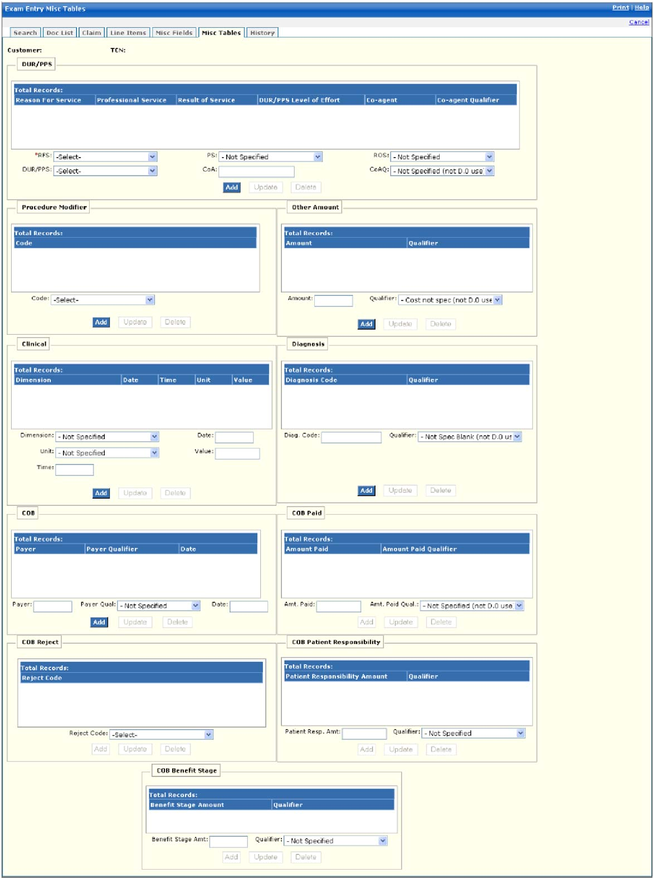

New Mexico PDCS OS PLUS Claims Subsystem
Window Exhibit
Adjustment Functional Group
Micellaneous Tables Window
Field Name | Table Column Name | Table Name | Format | Prot. (A,C,N) | Req.  (A,C,N) | Std. Edits | Specifications | Note  Ref.
Customer | R-CUST-PART-NUM | B_DETAIL_NM | 9,999 | A | N/A | N/A | Display Header
TCN | C_TCN_NUM | C_LI_DRUG_TB | X(17) | A | N/A | N/A | Displays the Transaction control number of particular claim.
DUR/PPS Results Display | N/A | N/A | N/A | N/A | N/A | N/A | Grouping
Reason for Service | R_RSN_FOR_SVC_CD | C_HDR_RLTD_HIST_TB | X(2) | A | N | V | Valid Values 8605
Professional Service | R_DUR_PPS_CD | C_HDR_DUR_PPS_TB | X(2) | A | N | N
Result of Service | R_DUR_RSLT_SVC_CD | C_HDR_DUR_PPS_TB | X(2) | A | N | N/A
DUR/PPS Level of Effort | C_DUR_LVL_EFRT_CD | C_HDR_DUR_PPS_TB | 9(2) | A | N | N/A
Co-agent | C_DUR_CO_AGT_ID | C_HDR_DUR_PPS_TB | X(19) | A | N | N/A
Co-agent Qualifier | C_DUR_CO_AGT_ID_CD | C_HDR_DUR_PPS_TB | X(2) | A | N | N/A
Total Records | N/A | N/A | Display | A | N | N/A | Computed as total number of DUR/PPS segments for claim
DUR/PPS Results Entry | N/A | N/A | N/A | N/A | N/A | N/A | Grouping
RFS | R_RSN_FOR_SVC_CD | C_HDR_DUR_PPS_TB | Drop-down | N | N | V | Valid Values 8605
DUR/PPS | C_DUR_LVL_EFRT_CD | C_HDR_DUR_PPS_TB | Drop-down | N | N | V | Valid Values 4634
PS | C_DUR_PPS_CD | C_HDR_DUR_PPS_TB | Drop-down | N | N | V | Valid Values 0834
CoA | C_DUR_CO_AGT_ID | C_HDR_DUR_PPS_TB | X(19) | N | C | N/A
ROS | C_DUR_RSLT_SVC_CD | C_HDR_DUR_PPS_TB | Drop-down | N | N | V | Valid Values 0881
CoAQ | C_DUR_CO_AGT_ID_CD | C_HDR_DUR_PPS_TB | Drop-down | N | N | V | Valid Values 4197
Command Buttons | Group | N/A | Button Row | N/A | N/A | N/A | Grouping
Add | N/A | N/A | Push Button | N | N | N/A | When the Add DUR/PPS button is selected, the new DUR/PPS row that has been entered is added.
Update | N/A | N/A | Push Button | N | N | N/A | When the Update DUR/PPS button is selected, the DUR/PPS row that has been changed is updated.
Delete | N/A | N/A | Push Button | N | N | N/A | When the Delete DUR/PPS button is selected, the DUR/PPS row that is selected is deleted. | R1
Procedure Modifier Display | N/A | N/A | N/A | N/A | N/A | N/A | Grouping
Code | R_PROC_MOD_CD | C_HDR_PROC_MOD_TB | X(2) | A | N | N/A
Total Records | N/A | N/A | Display | A | N | N/A | Computed as total number of procedure modifier segments for claim
Procedure Modifier Entry | N/A | N/A | N/A | N/A | N/A | N/A | Grouping
Code | R_PROC_MOD_CD | C_HDR_PROC_MOD_TB | Drop-down | N | N | V | Valid Values 0139
Command Buttons | Group | N/A | Button Row | N/A | N/A | N/A | Grouping
Add | N/A | N/A | Push Button | N | N | N/A | When the Add Procedure Modifier button is selected, the new Procedure Modifier row that has been entered is added.
Update | N/A | N/A | Push Button | N | N | N/A | When the Update Procedure Modifier button is selected, the Procedure Modifier row that has been changed is updated.
Delete | N/A | N/A | Push Button | N | N | N/A | When the Delete Procedure Modifier button is selected, the Procedure Modifier row that is selected is deleted. | R1
Clinical Display | N/A | N/A | N/A | N/A | N/A | N/A | Grouping
Dimension | C_CLIN_MSRMT_DM_CD | C_HDR_CLINICAL_TB | X(2) | A | N | N/A
Date | C_CLIN_MSRMT_DT | C_HDR_CLINICAL_TB | DATE | A | N | N/A | Format: MM/DD/CCYY
Time | C_CLIN_MSRMT_TM | C_HDR_CLINICAL_TB | TIME | A | N | N/A
Unit | C_CLIN_MSRMT_UN_CD | C_HDR_CLINICAL_TB | X(2) | A | N | N/A
Value | C_CLIN_MSRMT_DESC | C_HDR_CLINICAL_TB | X(15) | A | N | N/A
Total Records | N/A | N/A | Display | A | N | N/A | Computed as total number of clinical segments for the claim
Clinical Entry | N/A | N/A | N/A | N/A | N/A | N/A | Grouping
Dimension | C_CLIN_MSRMT_DM_CD | C_HDR_CLINICAL_TB | Drop-down | N | N | V | Valid Values 2649
Unit | C_CLIN_MSRMT_UN_CD | C_HDR_CLINICAL_TB | Drop-down | N | N | V | Valid Values 5234
Time | C_CLIN_MSRMT_TM | C_HDR_CLINICAL_TB | TIME | N | N | N
Date | C_CLIN_MSRMT_DT | C_HDR_CLINICAL_TB | DATE | N | C | D | Format: MM/DD/CCYY  Must be a valid date
Value | C_CLIN_MSRMT_DESC | C_HDR_CLINICAL_TB | X(15) | N | C | N/A
Command Buttons | Group | N/A | Button Row | N/A | N/A | N/A | Grouping
Add | N/A | N/A | Push Button | N | N | N/A | When the Add Clinical button is selected, the new Clinical row that has been entered is added.
Update | N/A | N/A | Push Button | N | N | N/A | When the Update Clinical button is selected, the Clinical row that has been changed is updated.
Delete | N/A | N/A | Push Button | N | N | N/A | When the Delete Clinical button is selected, the Clinical row that is selected is deleted.
COB Display | N/A | N/A | N/A | N/A | N/A | N/A | Grouping
Payer | C_PAYER_ID | C_HDR_COB_ID_TB | X(10) | A | N | N/A
Payer Qualifier | C_PAYERID_CD | C_HDR_COB_ID_TB | X(2) | A | N | N/A
Date | C_PAYERID_DT | C_HDR_COB_ID_TB | DATE | A | N | N/A | Format: MM/DD.CCYY
Total Records | N/A | N/A | Display | A | N | N/A | Computed as total number of COB payer Segments for claim
COB Entry | N/A | N/A | N/A | N/A | N/A | N/A | Grouping
Payer | C_PAYER_ID | C_HDR_COB_ID_TB | X(10) | N | C | N/A
Payer Qual | C_PAYERID_CD | C_HDR_COB_ID_TB | Drop-down | N | N | V | Valid Values 2337
Date | C_PAYERID_DT | C_HDR_COB_ID_TB | DATE | N | C | D | Format: MM/DD.CCYY  Must be a valid date
Command Buttons | Group | N/A | Button Row | N/A | N/A | N/A | Grouping
Add | N/A | N/A | Push Button | N | N | N/A | When the Add COB button is selected, the new COB row that has been entered is added.
Update | N/A | N/A | Push Button | N | N | N/A | When the Update COB button is selected, the COB row that has been changed is updated.
Delete | N/A | N/A | Push Button | N | N | N/A | When the Delete COB button is selected, the COB row that is selected is deleted.
Other Amount Display | N/A | N/A | N/A | N/A | N/A | N/A | Grouping
Amount | C_SUBM_OTHR_AMT | C_HDR_OTH_AMT_TB | X(7)V99 | A | N | N/A
Qualifier | C_SUBM_OTHR_AMT_CD | C_HDR_OTH_AMT_TB | X(2) | A | N | N/A | Valid Values 7805
Total Records | N/A | N/A | Display | A | N | N/A | Computed as total number of COB amount segments on the claim
Other Amount Entry | N/A | N/A | N/A | N/A | N/A | N/A | Grouping
Amount | C_SUBM_OTHR_AMT | C_HDR_OTH_AMT_TB | X(7)V99 | N | C | N
Qualifier | C_SUBM_OTHR_AMT_CD | C_HDR_OTH_AMT_TB | Drop-down | N | C | V | Valid Values 7805
Command Buttons | Group | N/A | Button Row | N/A | N/A | N/A | Grouping
Add | N/A | N/A | Push Button | N | N | N/A | When the Add Other Amt button is selected, the new Other Amt row that has been entered is added.
Update | N/A | N/A | Push Button | N | N | N/A | When the Update Other Amt button is selected, the Other Amt row that has been changed is updated.
Delete | N/A | N/A | Push Button | N | N | N/A | When the Delete Other Amt button is selected, the Other Amt row that is selected is deleted. | R1
Diagnosis Display | N/A | N/A | N/A | N/A | N/A | N/A | Grouping
Diagnosis Code | R_DIAG_CD | C_HDR_DIAG_TB | X(15) | A | N | N/A
Qualifier | C_DIAG_QL_CD | C_HDR_DIAG_TB | X(2) | A | N | N/A
Total Records | N/A | N/A | Display | A | N | N/A | Computed as total number of records meeting the search criteria
Diagnosis Entry | N/A | N/A | N/A | N/A | N/A | N/A | Grouping
Diag Code | R_DIAG_CD | C_HDR_DIAG_TB | X(15) | N | C | N/A
Qualifier | C_DIAG_QL_CD | C_HDR_DIAG_TB | Drop-down | N | N | V | Valid Value 1284
Command Buttons | Group | N/A | Button Row | N/A | N/A | N/A | Grouping
Add | N/A | N/A | Push Button | N | N | N/A | When the Add Diagnosis button is selected, the new Diagnosis row that has been entered is added.
Update | N/A | N/A | Push Button | N | N | N/A | When the Update Diagnosis button is selected, the Diagnosis row that has been changed is updated. | R1
Delete | N/A | N/A | Push Button | N | N | N/A | When the Delete Diagnosis button is selected, the Diagnosis row that is selected is deleted.
COB Paid Display | N/A | N/A | N/A | N/A | N/A | N/A | Grouping
Amount Paid | C_PAYERID_PD_AMT | C_HDR_COB_PAID_TB | X(7)V99 | A | N | N/A | N/A
Amount Paid Qualifier | C_PAYERID_PD_CD | C_HDR_COB_PAID_TB | X(2) | A | N | N/A
Total Records | N/A | N/A | Display | A | N | N/A | Computed as total number of records meeting the search criteria
COB Paid Entry | N/A | N/A | N/A | N/A | N/A | N/A | Grouping
Amt. Paid | C_PAYERID_PD_AMT | C_HDR_COB_PAID_TB | X(7)V99 | N | C | N
Amt. Paid Qual | C_PAYERID_PD_CD | C_HDR_COB_PAID_TB | Drop-down | N | N | V | Valid Values 8101
Command Buttons | Group | N/A | Button Row | N/A | N/A | N/A | Grouping
Add | N/A | N/A | Push Button | N | N | N/A | When the Add COB Paid button is selected, the new COB Paid row that has been entered is added.
Update | N/A | N/A | Push Button | N | N | N/A | When the Update COB Paid button is selected, the COB Paid row that has been changed is updated.
Delete | N/A | N/A | Push Button | N | N | N/A | When the Delete COB Paid button is selected, the COB Paid row that is selected is deleted. | R1
COB Reject Display | N/A | N/A | N/A | A | N | N/A | Grouping
Reject Code | C_PAYERID_REJ_CD | C_HDR_COB_REJ_TB | X(3) | A | N | N/A
Total Records | N/A | N/A | Display | A | N | N/A | Computed as total number of COB Reject segments for claim
COB Reject Entry | N/A | N/A | N/A | A | N | N/A | Grouping
Reject Code | C_PAYERID_REJ_CD | C_HDR_COB_REJ_TB | X(3) | N | N | V | Valid Value 4717
Command Buttons | Group | N/A | Button Row | N/A | N/A | N/A | Grouping
Add | N/A | N/A | Push Button | N | N | N/A | When the Add COB Reject button is selected, the new COB Reject row that has been entered is added.
Update | N/A | N/A | Push Button | N | N | N/A | When the Update COB Reject button is selected, the COB Reject row that has been changed is updated.
Delete | N/A | N/A | Push Button | N | N | N/A | When the Delete COB Reject button is selected, the COB Reject row that is selected is deleted. | R1
COB Patient Responsibility | N/A | N/A | N/A | N/A | N/A | N/A | Grouping
Patient Responsibility Amt Qualifier cd | C_COB_PAT_RESP_CD | C_HDR_COB_PAT_TB | X(3) | A | N | N/A | Valid Value 8626
Patient Responsibility Amt | C_COB_PAT_RESP_AMT | C_HDR_COB_PAT_TB | 9(8).9(2) | N | N
Total Records | N/A | N/A | Display | A | N | N/A | Computed as total number of COB Patient Responsibility values values for claim
COB Patient Responsibility entry | N/A | N/A | N/A | N/A | N/A | N/A | Grouping
Patient responsibility amt qualifier code | C_PAYERID_REJ_CD | C_HDR_COB_REJ_TB | X(3) | C | C | V | Valid Value 4717
Patient Responsibility Amt | C_COB_PAT_RESP_AMT | C_HDR_COB_PAT_TB | 9(8).9(2) | N | N
Command Buttons | Group | N/A | Button Row | N/A | N/A | N/A | Grouping
Add | N/A | N/A | Push Button | N | N | N/A | When the Add COB Patient Responsibility button is selected, the new COB Patient Responsibility row that has been entered is added.
Update | N/A | N/A | Push Button | N | N | N/A | When the Update COB Patient Responsibility button is selected, the COB Patient Responsibility row that has been changed is updated.
Delete | N/A | N/A | Push Button | N | N | N/A | When the Delete COB Patient Responsibility button is selected, the COB Patient Responsibility row that is selected is deleted. | R1
COB Benefit Stage | N/A | N/A | N/A | N/A | N/A | N/A | Grouping
Benefit Stage Qualifier cd | C_COB_BENE_ST_CD | C_HDR_COB_BENE_TB | X(3) | A | N | N/A | Valid Value 1890
Benefit Stage Amt | C_COB_BENE_ST_AMT | C_HDR_COB_BENE_TB | 9(8).9(2) | N | N
Total Records | N/A | N/A | Display | A | N | N/A | Computed as total number of COB Benefit Stage values for claim
COB Benefit Stage entry | N/A | N/A | N/A | N/A | N/A | N/A | Grouping
Benefit Stage qualifier code | C_COB_BENE_ST_CD | C_HDR_COB_BENE_TB | X(3) | C | C | V | Valid Value 4717
Benefit Stage Amt | C_COB_BENE_ST_AMT | C_HDR_COB_BENE_TB | 9(8).9(2) | N | N
Command Buttons | Group | N/A | Button Row | N/A | N/A | N/A | Grouping
Add | N/A | N/A | Push Button | N | N | N/A | When the Add COB Benefit Stage button is selected, the new COB Benefit Stage row that has been entered is added.
Update | N/A | N/A | Push Button | N | N | N/A | When the Update COB Benefit Stage button is selected, the COB Benefit Stage row that has been changed is updated.
Delete | N/A | N/A | Push Button | N | N | N/A | When the Delete COB Benefit Stage button is selected, the COB Benefit row that is selected is deleted. | R1
Legend
Prot. and Req. | Standard Edits | Note Ref.
A = Always | D = Date Edit | C = Customer-specific field or functionality
C = Conditionally | N = Numeric Edits | R = Note Reference
N = Never | S = System Generated
 | V = Valid Value Edit

Ref. No. | Notes
R1 | Confirmation is required for deletion.
New Mexico PDCS OS PLUS Claims Subsystem
Window Specification
Adjustment Functional Group
History Window

Window Name: Adjustment: History
Description:
Authorized users utilize the History Window to display only additional claim information along with related history. The Credit/Adjustment Information pane contains the TCN of the adjustment claim (in the Replacement TCN column), and the header contains the TCN of the original claim.

Window Type:
Response Window

Navigation:
The user enters this window by selecting the History tab.

Interface to Other Subsystem(s):
N/A

Interface to Other Application(s):
N/A

Special Security Requirements:
Access to data is controlled by the user’s security profile.

Presentation Sequence for Related History:
Line Item number, Exception Number

Remarks:
N/A

New Mexico PDCS OS PLUS Claims Subsystem
Window Layout
Adjustment Functional Group
History Window

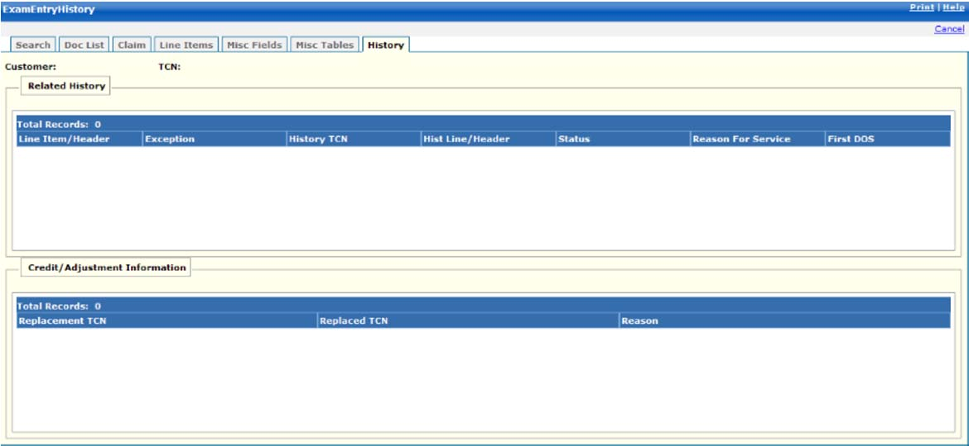

New Mexico PDCS OS PLUS Claims Subsystem
Window Exhibit
Adjustment Functional Group
HIstory Window
Field Name | Table Column Name | Table Name | Format | Prot. (A,C,N) | Req.  (A,C,N) | Std. Edits | Specifications | Note  Ref.
Customer | R-CUST-PART-NUM | B_DETAIL_NM | 9,999 | A | N/A | N/A | Display Header
TCN | C_TCN_NUM | C_LI_DRUG_TB | X(17) | A | N/A | N/A | Displays the Transaction control number of particular claim.
Related History | N/A | N/A | N/A | N/A | N/A | N/A | Grouping
Line Item/Header | C_LI_NUM | C_HDR_RLTD_HIST_TB | X(4) | A | N | N/A
Exception | R_CLM_EXC_CD | C_HDR_RLTD_HIST_TB | X(4) | A | N | N/A
History TCN | C_RLTD_LI_TCN_NUM | C_HDR_RLTD_HIST_TB | X(17) | A | N | N/A
Hist Line/Header | C_RLTD_LI_NUM | C_HDR_RLTD_HIST_TB | X(2) | A | N | N/A
Status | C_EXC_STAT_CD | C_HDR_RLTD_HIST_TB | X(1) | A | N | N/A | Valid value 4200
Reason for Service | R_RSN_FOR_SVC_CD | C_HDR_RLTD_HIST_TB | X(2) | A | N | N/A | Valid Value 8605
First DOS | C_HDR_SVC_FST_DT | C_LI_DRUG_TB | DATE | A | N | N/A | Format: MM/DD/CCYY
Total Records | N/A | N/A | Display | A | N | N/A | Computed as total number of records meeting the criteria
Credit/  Adjustment Information | N/A | N/A | N/A | N/A | N/A | N/A | Grouping
Replacement TCN | C_REPLCMT_TCN_NUM | C_HDR_ADJ_VD_TB | 9(17) | A | N | N/A
Replaced TCN | C_REPLCD_TCN_NUM | C_HDR_ADJ_VD_TB | 9(17) | A | N | N/A
Reason | C_HDR_ADJ_RSN_CD | C_HDR_ADJ_VD_TB | X(3) | A | N | N/A | Valid Value 0961
Total Records | N/A | N/A | Display | A | N | N/A | Computed as total number of records meeting the criteria

Legend
Prot. and Req. | Standard Edits | Note Ref.
A = Always | D = Date Edit | C = Customer-specific field or functionality
C = Conditionally | N = Numeric Edits | R = Note Reference
N = Never | S = System Generated
 | V = Valid Value Edit

Ref. No. | Notes
N/A | N/A

13.2.6.5 Mass Adjustment Functional Group

This functional group provides the user the ability to:

- Search a selection List
- Approve a selection List
- Reject a selection List
- Delete a selection TCN
- Go to previous 500 Selection TCNs
- Go to next 500 Selection TCNs
- Search a process List
- Approve a process List
- Reject a process List
- Delete a process TCN
- Go to previous 500 process TCNs
- Go to next 500 process TCNs

The following tab windows are used by the Mass Adjustment Functional Group:

- Mass Adjustment/Void
- Mass Adjustment Preview

New Mexico PDCS OS PLUS Claims Subsystem
Window Specification
Mass Adjustment Functional Group
Mass Adjustment/Void Tab Page

Window Name: Mass Adjustment: Adjustment Void Search
Description: Since a claims adjudication environment cannot be tuned to optimize both adjudication of real-time submission of pharmacy claims and ad hoc queries, the Data Warehouse, or Decision Support System (DSS) is used to build the list of TCNs that are to be mass adjusted. This is because developing the list of TCNs is typically an iterative process of executing queries and analyzing results. Clinical specialists, reporting specialists and Account Management work together to develop the DSS query that can produce the list of TCNs for claims with the characteristics of those needing adjustment.

Window Type:
Response Window

Navigation:
A user will select a search date from the Process Date selection drop-down. The Search Process list button is hit and a list of valid TCNs will be displayed.

Interface to Other Subsystem(s):
N/A

Interface to Other Application(s):
N/A

Special Security Requirements:
N/A

Presentation Sequence(s):
N/A
Remarks:
N/A

New Mexico PDCS OS PLUS Claims Subsystem
Window Layout
Mass Adjustment Functional Group
Mass Adjustment/Void Tab Page

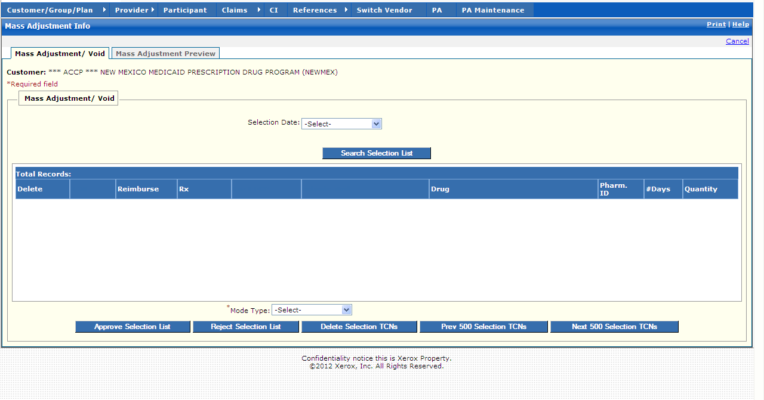

New Mexico PDCS OS PLUS Claims Subsystem
Window Exhibit
Mass Adjustment Functional Group
Mass Adjustment/Void Tab Page
Field Name | Table Column Name | Table Name | Format | Prot. (A,C,N) | Req.  (A,C,N) | Std. Edits | Specifications | Note  Ref.
Mass Adjustment/ Void Entry | N/A | N/A | N/A | N/A | N/A | N/A | Grouping
Customer | R_CUST_PART_NUM | CL-DRUG-TB | Display
Selection Date | C_MASS_ADJ_REQ_DT | CL-DRUG-TB | Drop-down
Command Button | Group | N/A | Button Row | N/A | N/A | N/A | Grouping
Search Selection List | N/A | N/A | Push Button | N | N | N/A | When pressed, TCN that falls within the date specified by the user are displayed in the table.
Mass Adjustment/ Void Display | Group | N/A | Group | N/A | N/A | N/A | Grouping
Delete | N/A | N/A | Checkbox | N/A | N/A | N/A
TCN | C_TCN_NUM | C-ADJ-SEL-TB | S9(17)V9(0) | A | A
Reimburse | C_TOT_REIMB_AMT | C-ADJ-SEL-TB | S9(9)v9(2) | A | A
Rx | C_RX_SVC_REF_NUM | C_LI_DRUG_TB | 9(12) | A | A
First DOS | C_HDR_SVC_FST_DT | C_LI_DRUG_TB | DATE | A | A
Adjudicated | C_HDR_ADJUD_DT | C_LI_DRUG_TB | DATE | A | A
Drug | R_DRUG_NAM | C_LI_DRUG_TB | X(30) | A | A
Pharm. ID | P_SVC_PHARM_ALT_ID | C_LI_DRUG_TB | X(15) | A | A
#Days | C_SUB_DAY_SPLY_AMT" | C_LI_DRUG_TB | S9(9)v9(2) | A | A
Quantity | C_DRUG_SUB_QTY_AMT | C_LI_DRUG_TB | S9(9)v9(2) | A | A
Total Records | N/A | N/A | Display | A | N | N/A | Computed as total number of records meeting the search criteria
Mode Type | N/A | N/A | DropDown | N | C |  | V - Void  P - Adjustment  D - Re-adjudicate(denied Claims)
Command Buttons | Group | N/A | Button Row | N/A | N/A | N/A | Grouping
Approve Selection List | N/A | N/A | Push Button | N | N | N/A | When the Approve Selection List button is selected, the selection list that is selected is approved..
Reject Selection List | N/A | N/A | Push Button | N | N | N/A | When the Reject Selection List button is selected, the selection list that is selected is rejected..
Delete Selection TCN | N/A | N/A | Push Button | N | N | N/A | When the Delete Selection TCN button is selected, the selected TCN is deleted
Prev 500 Selection TCNs | N/A | N/A | Push Button | N | N | N/A | When the Prev 500 Selection TCNs button is selected, the table displays the previous 500 TCNs.
Next 500 Selection TCNs | N/A | N/A | Push Button | N | N | N/A | When the Next 500 Selection TCNs button is selected, table displays the next 500 TCNs.

Legend
Prot. and Req. | Standard Edits | Note Ref.
A = Always | D = Date Edit | C = Customer-specific field or functionality
C = Conditionally | N = Numeric Edits | R = Note Reference
N = Never | S = System Generated
 | V = Valid Value Edit

Ref. No. | Notes
N/A | N/A

New Mexico PDCS OS PLUS Claims Subsystem
Window Specification
Mass Adjustment Functional Group
Mass Adjustment Preview Tab Page

Window Name: Mass Adjustment: Adjustment Preview Search
Description:
Since a claims adjudication environment cannot be tuned to optimize both adjudication of real-time submission of pharmacy claims and ad hoc queries, the Data Warehouse, or Decision Support System (DSS) is used to build the list of TCNs that are to be mass adjusted. This is because developing the list of TCNs is typically an iterative process of executing queries and analyzing results. Clinical specialists, reporting specialists and Account Management work together to develop the DSS query that can produce the list of TCNs for claims with the characteristics of those needing adjustment.

Window Type:
Response Window

Navigation: A user will select a search date from the Process Date selection drop-down. The Search Process list button is hit and a list of valid TCNs will be displayed.

Interface to Other Subsystem(s):
N/A

Interface to Other Application(s):
N/A

Special Security Requirements:
N/A

Presentation Sequence(s):
N/A

Remarks:
N/A

New Mexico PDCS OS PLUS Claims Subsystem
Window Layout
Mass Adjustment Functional Group
Mass Adjustment Preview Tab Page

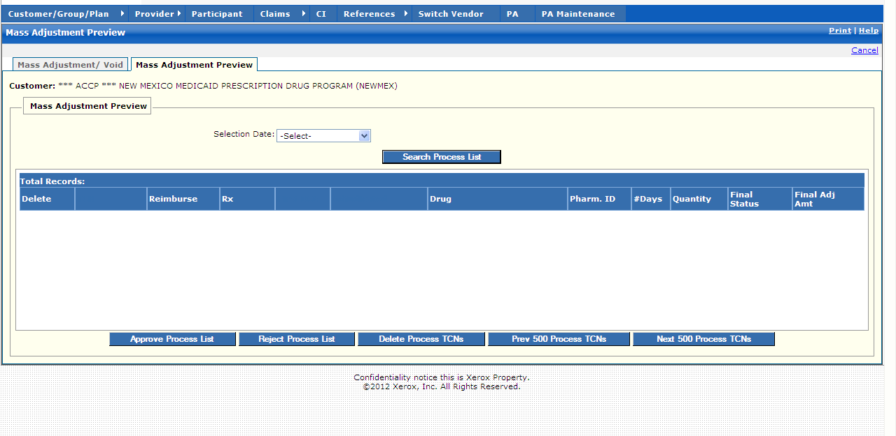

New Mexico PDCS OS PLUS Claims Subsystem
Window Exhibit
Mass Adjustment Functional Group
Mass Adjustment Preview Tab Page
Field Name | Table Column Name | Table Name | Format | Prot. (A,C,N) | Req.  (A,C,N) | Std. Edits | Specifications | Note  Ref.
Customer | R_CUST_PART_NUM | CL-DRUG-TB | Display
Mass Adjustment Preview Entry | N/A | N/A | N/A | N/A | N/A | N/A | Grouping
Selection Date | C_MASS_ADJ_REQ_DT | CL-DRUG-TB | Drop-down
Command Button | Group | N/A | Button Row | N/A | N/A | N/A | Grouping
Search Process List | N/A | N/A | Push Button | N | N | N/A | When pressed, TCN that falls within the date specified by the user are displayed in the table.
Mass Adjustment Preview Display | N/A | N/A | Group | N/A | N/A | N/A | Grouping
Delete | N/A | N/A | Checkbox | N/A | N/A | N/A
TCN | C_TCN_NUM | C-ADJ-PR-TB | S9(17)V9(0) | A | A
Reimburse | C_TOT_REIMB_AMT | C_LI_DRUG_TB | S9(9)v9(2) | A | A
Rx | C_RX_SVC_REF_NUM | C_LI_DRUG_TB | 9(12) | A | A
First DOS | C_HDR_SVC_FST_DT | C_LI_DRUG_TB | DATE | A | A
Adjudicated | C_HDR_ADJUD_DT | C_LI_DRUG_TB | DATE | A | A
Drug | R_DRUG_CD | C_LI_DRUG_TB | X(30) | A | A
Pharm. ID | P_SVC_PHARM_ALT_ID | C_LI_DRUG_TB | X(15) | A | A
#Days | C_SUB_DAY_SPLY_AMT | C_LI_DRUG_TB | S9(9)v9(2) | A | A
Quantity | C_DRUG_SUB_QTY_AMT | C_LI_DRUG_TB | S9(9)v9(2) | A | A
Final Status | C_HDR_STAT_CD | C-ADJ-PR-TB | CHAR(1) | A | A
Final Adj Amt | C_TOT_REIMB_AMT | C-ADJ-PR-TB | S9(9)v9(2) | A | A
Total Records | N/A | N/A | Display | A | N | N/A | Computed as total number of records meeting the search criteria
Command Buttons | Group | N/A | Button Row | N/A | N/A | N/A | Grouping
Approve Process List | N/A | N/A | Push Button | N | N | N/A | When the Approve Process List button is selected, the selected Process list is approved.
Reject Process List | N/A | N/A | Push Button | N | N | N/A | When the Reject Process List button is selected, the selected Process list is rejected..
Delete Process TCN | N/A | N/A | Push Button | N | N | N/A | When the Delete Process TCN button is selected, the selected TCN is deleted
Prev 500 Process TCNs | N/A | N/A | Push Button | N | N | N/A | When selected, the table displays the previous 500 TCNs.
Next 500 Process TCNs | N/A | N/A | Push Button | N | N | N/A | selected, table displays the next 500 TCNs.

Legend
Prot. and Req. | Standard Edits | Note Ref.
A = Always | D = Date Edit | C = Customer-specific field or functionality
C = Conditionally | N = Numeric Edits | R = Note Reference
N = Never | S = System Generated
 | V = Valid Value Edit

Ref. No. | Notes
N/A | N/A

